DVD Renting system for Southern DVD Center

**British Computer Society**

**Professional Graduate Diploma**

**Professional Project**

**Candidate Name: Dilini Sewwandi Rajapaksha**

**Candidate Number: 990101692**

Table of Contents

1 Abstract 4

2 Requirements Analysis 5

2.1 Description of the organization 5

2.2 How the current system works 6

2.3 Overall problem description 7

2.4 Fact finding of the system 8

2.5 Fact finding by interviews 8

2.5.1 Plan for the interview with the shop owner 8

2.5.2 Transcripts of the interview with the Owner 10

2.5.3 Interview with the cashiers at Southern DVD Canter 14

2.5.4 Transcripts of the interview with the cashier 14

2.6 Fact finding of the system by inspecting documents 17

2.6.1 DVD rental book 17

2.6.2 Customer book 18

2.6.3 DVD inventory book 18

2.7 Detailed description of the business procedures 20

2.8 Detailed description of the problems in the current system 21

2.9 Alternative solutions considered 22

2.9.1 Customization of a database package 22

2.9.2 Solution implemented as a spreadsheet 22

2.9.3 Solution implemented through custom programming 22

2.9.4 Justification of the choice of solution 23

2.10 Hardware Requirements 24

2.11 Software Requirements 25

2.12 Requirements of the New System received from the user 26

2.13 Use case model of the system 27

2.14 Prototype of User Interfaces 28

2.15 Detailed requirements specification 31

2.16 Requirements confirmation of the New System 33

2.17 Comments on the System Requirements Document by the Customer 34

3 Initial project schedule 35

4 System Design 36

4.1 System Detailed Design 36

4.1.1 Sequence Diagram 37

4.1.2 Data model of the system 38

4.1.3 Database Design 39

4.1.4 User interface Design and Business Logic 40

4.2 Test plan 43

4.2.1 Functional/System Testing 43

4.2.2 Unit testing 43

4.2.3 Integration testing 43

5 Implementation 44

5.1 Technologies to be used in development 44

5.1.1 Programming language 44

5.1.2 RDBMS 45

5.1.3 Other technologies and APIs Used 46

5.1.4 Development Environment 47

5.2 Program listings 47

5.2.1 Implementation and Program listings of the views 47

5.2.2 Program listings of the Controller component 61

5.2.3 Program listings of the Data models 79

5.2.4 Configuration Files 83

5.3 Database Implementation 84

5.3.1 Customer Table 85

5.3.2 DVD Table 86

5.3.3 Transaction Table 87

5.3.4 User Role Table 88

6 Testing 89

6.1 Functional Testing 89

6.1.1 Basic functionality testing 89

6.1.2 Validation testing 103

7 Critical Appraisal 107

Table of Figures

Figure 2‑1: Use case Diagram 27

Figure 2‑2: The Login Screen 28

Figure 2‑3: The Main Screen 29

Figure 2‑4: The DVD Screen 30

Figure 4‑1: Sequence diagram 37

Figure 4‑2: Class Diagram 38

Figure 4‑3: User interface architecture 40

Figure 4‑4: Change password screen 41

Figure 4‑5: Architecture of Controller 42

Figure 5‑1: Login View 47

Figure 5‑2: Main View 50

Figure 5‑3: DVD view 57

Figure 5‑4: Database tables 84

Figure 5‑5: Customer Table 85

Figure 5‑6: DVD Table 86

Figure 5‑7: Transaction Table 87

Figure 5‑8: User Table 88

Figure 6‑1:FT1 Before 92

Figure 6‑2: FT1 After 93

Figure 6‑3: FT1 Database 93

Figure 6‑4: FT2.1 Before Adding 94

Figure 6‑5: FT2.1 After Adding 95

Figure 6‑6: FT2.2 Before saving 96

Figure 6‑7: FT2.2 After saving 97

Figure 6‑8: FT2.2 Database 97

Figure 6‑9: FT3.1 Before lending 98

Figure 6‑10: FT3.1 After lending 99

Figure 6‑11: FT3.2 After Saving 100

Figure 6‑12: FT3.2 Database 101

Figure 6‑13: FT6 101

Figure 6‑14: FT6 101

Figure 6‑15: FT7.1 102

Figure 6‑16: FT7.2 102

Figure 6‑17: VT1 104

Figure 6‑18: VT2 104

# Abstract

The Southern DVD Company runs a small scale DVD renting business. They rent a wide variety of CDs and DVDs in the fields of Music, Movies, Games, Documentary, Educational, software, and a lot more.

They face difficulties with the manual system they use and need to fully automate the current system to provide their services more efficiently.

The objective of this project is to automate the manual system currently used at Southern DVD. The proposed deliverables are a fully working software system with relevant documentation.

This is a software development project which involves all the stages of a software development life cycle. The software system developed for the Southern DVD Center will consist of a client application and a database server. The system is proposed to implement in a single computer but can be used in a networked environment since it has the client server architecture.

# Requirements Analysis

The initial requirements gathering was done by observation and further requirements analysis was conducted by using two main fact finding techniques.

## Description of the organization

The owner of the ‘Southern DVD Canter’ is Mr. Rathnayaka who started the business of DVD renting two years ago along with his brother. It is a small scale business which was started with a small collection of movie DVDs at their own place. As a result of the good profit they earned, they bought a small showroom for rent nearby and opened a DVD shop in year 2008.

At the beginning Mr. Rathnayaka and his brother were managing all the work in the shop but it has grown out of their scope with the increase of number of customers and the demand. Since they make a good profit they have hired 2 more employees and planning to appoint one of them as a cashier and the other as a shop assistant since the owner have other responsibilities like buying and managing stock, checking accounts and other administrative tasks. The shop assistant is there for customer care, and they cannot interfere in any of the issues regarding cashier. The cashier is responsible for all the money transactions, any losses, recording information and keeping them safe, providing any required information to the owners at any given time.

Even though the name of the shop is Southern DVD Canter, you can find a variety of DVDs like Documentary, Educational, Software, Games. The movie DVD collection consists of movies of many languages, such as English, Hindi, Tamil, Sinhala and the DVDs have been categorized in to various types such as horror, comedy. Hindi movies are imported directly from India whereas the others are purchased from wholesale shops in Sri Lanka. There are no pirated DVDs/VCDs available for renting and only original DVDs are available in the showroom for rent.

## How the current system works

When I asked about the current system of the shop, MR. Rathnayaka mentioned that renting is currently handled manually but they are considering moving to a computerized system since the business is growing fast and they find it hard to handle manually. He also mentioned that they find it quite risky to invest on a computerized system because the cost is high and they are not sure how much they can benefit from it. I thought of developing a solution for the Southern DVD Canter as my BCS project, and with that intension in my mind I told him, that I can develop a renting system for them with no cost at all and also acknowledged that I will be presenting it as my BCS project. He was glad to hear my idea and he expressed his willingness to provide me with details about the data and procedures followed in connection to DVD renting. He explained me further about the system that is being handled currently. He even invited me to come along with him to their shop and see how they work in order to get an idea about how the things are handled manually and the daily business process. I was glad since this chance would also give me the opportunity to observe how they carry out the business procedures and also to examine the documents involved with the business.

There were plenty of customers in the shop and the employees were busy managing the work. Therefore I couldn’t talk with any of the workers since I didn’t want to disturb them on their work, yet I observed many things and got a pretty good idea about the process. The process of the renting DVDs and dealing with their customers seemed to be as follows;

Customers who come to borrow DVDs mostly search them from the DVD shelves.

Yet sometimes customers come asking for certain movies giving their names to the assistants.

Then the shop assistant checks for the particular DVDs on the shelves and give them if available.

Once they choose the DVDs they go to the cashier and do the payments.

The cashier asks for customer information and search through a book to see if there are any previous records of the particular customer. If he could not find the information a new customer record has to be added.

Then the cashier calculates the rent and the deposit and charge the deposit.

Some customers come to return DVDs and then the cashier did some calculations and refunded the deposited amount and which is a time consuming task.

The cashier asked one of the shop assistants to check the returned DVD and put it back to the shelf.

## Overall problem description

Whenever a customer comes asking for a particular DVD, to find whether a DVD is in or out is time consuming with the manual system since the shop assistants have to check all the DVDs to find it out and even if the DVD is not available the customer has to wait for a long time.

The owners need to see the net income and the amount they should keep for return as deposit at the end of the day. The cashiers are finding it difficult to handle all the processing of transaction information and calculations daily since they keep all the records manually. It is time consuming as well as calculations could be incorrect.

When the customers need to lend DVDs, since the cashier got to manage all the work the manual documents, to check on customer’s membership and other details and to calculate the fines it takes so much of time and customers do not like it.

There is no security for documents which contains all the business data. All the data regarding transactions, customers, DVDs, are in paper documents and has been kept in a drawer where everyone is able to refer. The customers are complaining for disclosing their personal information such as contact number. The documents get misplaced and damaged therefore unable to use when required.

Cashier finds it hard to handle all transaction operations manually since many calculations ought to be done. When calculating the fines to be charged due to delayed returns the cahier has to go through all the documents which contain past transaction data.

## Fact finding of the system

Since Southern DVD Canter is a small scale business, there were very few employees and a few will be using the proposed system. Therefore it was decided to gather requirements using the following techniques.

1. Fact finding by interviews.
2. Fact finding by inspecting documents.

## Fact finding by interviews

Even though interviews are time consuming it is one of the best techniques to gather most important information, therefore the shop owner and one of the employees were interviewed.

### Plan for the interview with the shop owner

Since the owner is the head of the store, I planned to interview him first because it was expected that the outcome of that interview would help in identifying the other employees to be interviewed.

An appointment was made to have this interview at 9:00AM on the Sunday, 24th October 2010 at the owner’s cabin. It has also been decided to obtain the details about the documentation used in the shop.

A set of questions were prepared to ask from the shop owner in order to get a clear idea about their business procedures and the problems that they come across while using the manual system.

#### The actual set of questions that had been pre-planned to ask from the owner is as follows:

1. What are the types of transactions that take place in your business?
2. How frequently do you buy stock (DVDs)?
3. As per my understanding you record details of three main elements which are Stock (DVDs), Customer and Transactions, other than those, do you record any other kind of data or information?
4. What are the stocks details that you record?
5. What are the customer details that you record?
6. What are the transaction details that you record?
7. Who is responsible for recording each of the above details?
8. Who are the employees that are authorized to view, modify or record the above mentioned details?
9. Which data do you expect to store in the new system?
10. How many days you allow the customer to keep the borrowed DVDs?
11. About how many DVDs you give out for rent at a time for a customer?
12. How do you manage returning DVDs on closed days? If the DVD due date falls on to a holiday then how the payments would be?
13. Do you allow customers to lend more DVDs if they have unreturned DVDs already?
14. Is there any fine charging in case of a delayed return or damaged DVDs?
15. What are the reports that you expect the system to generate?

In addition to the above questions it was decided to request the owner to suggest a name of an employee from whom I would be able to get useful information about the current business process.

### Transcripts of the interview with the Owner

Analyst: Hi Mr. Rathnayaka, Good morning! I hope that I am on time for our meeting.

Owner: Hi Ms. Dilini, Good morning! Yes of cause you are exactly on time.

Analyst: So I don’t want to waste any time and let’s get in to our business because I know how busy you are and how precious the time is for you. First of all could you please describe to me the main types of transactions that take place in your business?

Owner: our main transactions are buying and renting DVDs.

Analyst: Okay. In that case do you want me to automate both of these transaction processing?

Owner: Actually yes. We want the new system to support both types of transactions since we are planning to hand over the responsibility of buying and renting to our employees we need to keep track of both.

Analyst: So as I understand renting is the most frequent transaction that happens and I would like to know how frequently you buy stock (DVDs)?

Owner: Normally once a month, and if a new movie has been released, which of high demand we would buy it immediately.

Analyst: About how many DVDs do you buy normally?

Owner: It usually depends on the current trend, and we also replace damaged ones with new, so the numbers vary from about 10 to 20.

Analyst: I understand that you buy several copies of one DVD.

Owner: Yes of course.

Analyst: Okay then could you explain me a bit as per your knowledge what is normally happening when a customer comes to the shop?

Owner: Depending on the customer’s wish, either my one of the assistants will help them in finding their required DVDs or they are free to go and choose them on their own.

Analyst: okay. Do you expect the new system to have any options on customer care, I mean a feature which would be helpful to your customers?

Owner: Actually I don’t expect such features, since I have my assistants for customer care, and I am happy with their work.

Analyst: As per my understanding you record details of three main elements which are Stock (DVDs), Customer and Transactions, other than those, do you record any other kind of data or information?

Owner: Yes, you are correct, we keep records on purchased DVDs, daily transactions, and even we keep details of our customers and additionally we keep records of certain statistics like how many DVDs were rented on a particular day and how much cash we hold as deposits etc...

Analyst: It was really important piece of information. In that case do you expect the new system to have security options to protect the sensitive or confidential data?

Owner: Yes exactly. That is one of the main important point I wanted to tell you because normally we record customer’s contact information and some other personal data, in our books and that is really unfair for our customers since anybody can refer their information. Even we have got quite a few complaints from our customers regarding that issue.

Analyst: I will make sure you will get over of that problem when using the new system. Well could you briefly explain me on your business policies regarding DVD renting? Like how many DVDs you give for rent at a time for a customer and for how long can he keep it?

Owner: I have told my employees not to allow the customers to borrow more than three DVDs at a time. And they have to return it within7 days. If three days exceed then we will be charging a fine of Rs.25.00 per each delayed day.

Analyst: What happens if a customer borrows three DVDs and return only one DVD within the maximum number of days that he could keep?

Owner: Yes he can do that but he will have to pay an extra amount for each extra day he is going to keep, in this case for both the DVDs he will have to pay a fine of 50 per day.

Analyst: Okay but when a particular customer has unreturned DVDs with him do you allows him to borrow more?

Owner: yes. Actually that depends on the number of unreturned DVDs he has. If he has only one unreturned DVD with him then he can borrow another two DVDs. But if he has maximum of three DVDs he cannot borrow any other until he returns the previous ones and pay the delayed fine.

Analyst: All right. I think I got some idea about the business policies. Now I want to find out the DVDs that are stored in this showroom and how they are categorized?

Owner: Here is the list of the DVDs we give for rent here (he produces a document that mentions the DVD names, Types, and prices).

Analyst: could you please provide me with the relevant documents of the stock details, the customer details and the transaction details that you record so that I can note down the particular details that you record for each?

Owner: provided three books mentioning that they contained transaction details and customer details and stock details.

Analyst: Well tell me briefly what do you expect from the new system?

Owner: I want to use the new system to store the records of transactions and to keep backups of them because there are some really important documents which I find hard to manage manually. And to check the DVDs which I give for rent within one day, likewise to easily calculate my daily income and so on. And even some security options to our confidential data.

Analyst: This conversation was really helpful for me in identifying your desired requirements. Right now I got a better idea about your shop and business procedures, if you figure out any other issues, kindly give me a call and inform. So then I can fix another day to meet you and discuss about it. May I know if there are any employees to whom I could talk and gather more information about the issues they get to face since they are ones who will use this system in future?

Owner: Yes of course. You will be able to talk to our cashier and gather more information because he is the one who is responsible for many tasks like recording data, money transactions and all. I think if you get to talk to him it will be of some use.

Analyst: Ok thank you very much for the information. I will try my level best to come up with a good solution for the problems. As soon as I decide that, I will inform you.

Owner: Ok. Thank you. I’m looking forward to it. All the very best!

### Interview with the cashiers at Southern DVD Canter

As Mr. Rathnayaka said that I will be able to gather more information about the current business procedures and other business issues regarding DVD renting from their cashiers it was decided to interview one of them even though I didn’t have any pre-planned set of questions to interview the cashier. But since I felt this would be a great opportunity to get a good knowledge about the workers and to observe their working site, I met the cashier at Southern DVD Canter. Since they were busy with some customers I decided to wait for a while and observe their working strategy. After some time one of the cashiers came to me and welcomed me since Mr. Rathnayaka has informed them about the purpose of my visit.

### Transcripts of the interview with the cashier

Analyst: Hi I am Dilini. I hope Mr. Rathnayaka has told you about the purpose of this meeting.

Cashier: Yes. Our boss told me about the new computerized system that you are going to develop. It is my pleasure if this meeting helps you on your work.

Analyst: Of course it would be helpful. First of all may I know since when you are working in this shop?

Cashier: Now it has been more than a year since I started working here.

Analyst: Could you tell me the details on your involvement for the daily transactions?

Cashier: I am the one who handle all money transactions with regard to renting DVDs. We have to keep records of all the transactions as well.

Analyst: Tell me you keep records manually with regard to DVD renting.

Cashier: Normally when a customer comes to lend DVDs first of all I take down their details like name, NIC and contact number because I have been asked to do that from our management. After that I keep the records of the transaction in a separate book.

Analyst: So can you describe me all the work that you have to manage while renting DVDs. Because I need to know all the hardships that you come across, so then I can find proper solutions to them and develop a system where you can easily work with.

Cashier: I would be really grateful for that. Because now I am struggling to complete my work within a day since this manual work is so time consuming and even difficult when there are plenty of customers.

Analyst: Go ahead and tell me what difficulties you find while working manually. Feel free to tell me anything regarding this issue because you would be benefited in future if the new system could avoid all your difficulties.

Cashier: It is difficult for me to maintain books, keeping all the records manually because it consumes so much of time. When there are number of customers, they have to wait in a queue till I take down each customer’s details and then calculate fines and refunding deposits. Sometimes the customers get mad at me for keep them waiting for long. The main problem is I get confused and do incorrect calculations when I am in a hurry and tension due to too many customers.

Analyst: You mean to say that it’s hard to keep manual records?

Cashier: yes. When customers come to return DVDs I have to go through all the past transaction details documents and even then sometimes I am unable to find because in the shop we misplace many documents. In those cases I have to depend on the customer’s saying about the lent date and other.

Analyst: I think I got some idea about it. Tell me, Do you get any complains when you fail to manage work properly due these reasons.

Cashier: Yes. Quiet a lot. Customers complain that I am charging wrong amounts due to misplacements of transaction data. And another main problem is customers complain me that their contact numbers are getting disclosed to many people around and it has become nuisances for them so they are backing off to provide me the contact numbers. At the same time our management does not allow me to give any DVD for rent without taking down the customer’s contact.

Analyst: Its good you told that. Is there any other problem that you currently face?

Cashier: Actually those were the main problems I had in my mind.

Analyst: Ok thanks for the cooperation. If you come across any other problems please let Mr. Rathnayaka know that so then he can contact me and inform me.

Cashier: yes. If there is any, I surely will. Thank you.

## Fact finding of the system by inspecting documents

The following documents have been inspected, which are used in the operations carried out in the business.

* DVD rental book
* Customer details book
* Video inventory book

### DVD rental book

This book is kept on the cashier’s table and this is used when transactions of renting has been done. In this log book they keep records, on each and every transaction i.e. DVD ID (every DVD has a unique ID), DVD name, date rented, date returned, customer name. A sample of the records in the DVD book is given below.

|  |  |  |  |  |
| --- | --- | --- | --- | --- |
| DVD ID | DVD name | Date rented | Date to be returned | Customer No. |
| 10018 | Harry Potter2 | 04.05.08 | 11.05.08 | 45 |
| 10028 | Bride and Prejudice | 04.05.08 | 11.05.08 | 109 |
| 20045 | Hum Tum | 04.05.08 | 11.05.08 | 23 |
| 20043 | Jab we met | 04.05.08 | 11.05.08 | 56 |
| 10033 | Mission Impossible2 | 04.05.08 | 11.05.08 | 154 |
| 10051 | A Cinderella story | 04.05.08 | 11.05.08 | 26 |
| 20027 | Veer Zara | 05.05.08 | 12.05.08 | 123 |
| 20025 | Josh | 05.05.08 | 12.05.08 | 123 |
| 10054 | A walk to remember | 05.05.08 | 12.05.08 | 45 |
| 20012 | Kuch kuch hota hai | 05.05.08 | 12.05.08 | 113 |
| 10024 | Narnia | 05.05.08 | 12.05.08 | 167 |
| 20064 | Rab ne bana di jodi | 06.05.08 | 13.05.08 | 167 |

Table 2‑1: A sample page of the DVD log book

### Customer book

When a customer comes to lend a DVD the customer log book has to be checked and if the particular customer’s details are already recorded then the DVD can be given. If not the particular customer details has to be in order to lend a DVD.

The customer book includes the records of the customers like name, contact, email etc… the email address was an optional field. There were about 2 customer log books.

|  |  |  |  |
| --- | --- | --- | --- |
| No | Name | Contact | Email |
| 1 | Dilip Fernando | 0112784234 | [dilipf2@yahoo.com](mailto:dilipf2@yahoo.com) |
| 2 | K. S. Gamage | 0112345345 | [kamalsg@gmail.com](mailto:kamalsg@gmail.com) |
| 3 | Ranuka De Silva | 0112738567 |  |
| 4 | Zameena Salam | 0112788004 | zamz94@yahoo.com |
| 5 | Dilani Gunethilaka | 0112723234 |  |

Table 2‑2: Structure of the Customer log book

### DVD inventory book

In this log book they record all the details about each and every stock of DVDs that they purchase. When new DVDs are purchased, this book will be updated. In this they record DVD ID, DVD Title, supplier, purchased price, Selling price, rental price and number of copies.

|  |  |  |  |  |  |  |  |  |
| --- | --- | --- | --- | --- | --- | --- | --- | --- |
| DVD category | DVD ID | | DVD title | Purchased price | Selling price | Rental price | Stock number | Number of Copies |
| English | 10018 | Harry Potter2 | | Rs.200 | Rs.350 | Rs.80 | 0014 | 5 |
|  | 10028 | Bride and Prejudice | | Rs.200 | Rs.350 | Rs.80 | 0014 | 1 |
|  | 10033 | Mission Impossible2 | | Rs.200 | Rs.350 | Rs.80 | 0014 | 3 |
|  | 10051 | A Cinderella story | | Rs.200 | Rs.350 | Rs.80 | 0014 | 1 |
|  | 10054 | A walk to remember | | Rs.180 | Rs.300 | Rs.50 | 0015 | 2 |
|  | 10024 | Narnia | | Rs.180 | Rs.300 | Rs.50 | 0015 | 3 |
|  | 10057 | Snakes in a plane | | Rs.180 | Rs.300 | Rs.50 | 0015 | 2 |
|  | 10023 | Note book | | Rs.180 | Rs.300 | Rs.50 | 0015 | 2 |
| Hindi | 20045 | Hum Tum | | Rs.210 | Rs.380 | Rs.50 | 0014 | 3 |
|  | 20043 | Jab we met | | Rs.210 | Rs.380 | Rs.50 | 0014 | 3 |
|  | 20027 | Veer Zara | | Rs.210 | Rs.380 | Rs.50 | 0014 | 4 |
|  | 20025 | Josh | | Rs.210 | Rs.380 | Rs.50 | 0014 | 2 |
|  | 20012 | Kuch kuch hota hai | | Rs.250 | Rs.400 | Rs.50 | 0015 | 2 |
|  | 20064 | Rab ne bana di jodi | | Rs.250 | Rs.400 | Rs.50 | 0015 | 3 |
|  | 20086 | Kal ho na ho | | Rs.250 | Rs.400 | Rs.50 | 0015 | 2 |
|  | 20074 | Main hoon na | | Rs.250 | Rs.400 | Rs.50 | 0015 | 2 |
| Horror | 30021 | Bride of chucky | | Rs.180 | Rs.300 | Rs.75 | 0014 | 3 |
|  | 30019 | X files | | Rs.180 | Rs.300 | Rs.75 | 0014 | 1 |

Table 2‑3: A sample page of the Transactions log book

## Detailed description of the business procedures

The details that were found from fact finding methods, including the interviews that were conducted with the owner is given below:

The shop assistants would help the customers to choose the DVDs of their taste by showing different categories of DVDs. i.e. if a customer wishes to borrow some horror movies then the assistant would show the particular section which has only horror movies (Therefore it’s easy for the customers to go through only the movies that he is interested in) or the customer themselves can choose.

Customer details are recorded before renting any DVD.

Duration is one week (7 days). If it exceeds the specified period of time then a fine of Rs. 25 per day is charged.

When a customer comes to return DVD/s the cashier check the borrowed date and calculate the amount to be charged.

If there is any fine (if the customer has kept the DVD for more than a week), then the amount to be charged = deposit - (rent + fine) (This value is calculated at the time of return)

Normally once a week the DVDs are checked for damages. If any damaged DVDs found, those will be discarded and will be replaced with the new DVDs. All these actions will be done by the shop assistant and will be noted with dates.

When purchasing DVDs for lending purpose, all the records regarding the transactions will be recorded. New are added to collection & recorded the no of copies, the name type and each is given a number.

## Detailed description of the problems in the current system

Since the current system is manual, they keep documents to record details of the daily transactions which make it really hard to find the information when required urgently. When a customer ask for a particular DVD for rent, it is hard to check whether it's available or not. (All the copies of the specific DVD has already given for rent & not returned yet)

The owner needs to see the net income of the day in order to calculate the amount that he should keep for return as deposit for the following day at the end of the day. The cashier finds it really hard to go through all the written documents and to provide the specific details to the owner and sometimes come up with inaccurate results.

They find it hard to calculate the fines because when a plenty of customers come at the same time the cashier will be in a hurry.

There is no security for documents which contains all the business data. All the data regarding transactions, customers, DVDs, are in manual paper documents and has been kept in a drawer where everyone is able to refer. The customers are complaining for disclosing their personal information such as contact number. The manual documents get misplace and damage therefore unable to use when required.

## Alternative solutions considered

### Customization of a database package

The new system can be developed by customizing a database package. The data storage is developed as a relational database. The database package should have built-in features to develop data entry screens and the information output screens. The database package should be able to implement security to the data. The database should have capability to perform calculations and other data processing functions. The package should also contain the tools to develop queries needed to extract information from the data storage.

### Solution implemented as a spreadsheet

The new system can be developed by using a spreadsheet package. The data is stored on the worksheets of the spreadsheet package. The spreadsheet package should have tools to develop user interfaces for data entry and output. The package should also have features to search for information.

### Solution implemented through custom programming

The data storage of the new system would be developed by using a database package as a relational database. The user interfaces for data entry and information output is developed using custom programming with a suitable high level programming language. In this solution the data storage and the user interfaces are developed independently from one another. The calculations, search for information and other data processing functions would be coded behind the user interface.

### Justification of the choice of solution

The solution based on the customization of the database package has the drawback of its inability to be implemented as a network system if the company decided to use more than one computer to implement the system. For example if the number of checkout counters is increased the database has to implemented as a central data storage which would be accessed through a number of workstations which have to have the user interfaces installed on them. This separation of the user interface from the data storage cannot be done when the system is developed by customizing a database package. The advantage of the database solution is that the querying, calculations and other data processing functions occur very fast because the data is transferred between the components of the same package.

The solution based on the spreadsheet has the drawback in the data storage. Here the data storage cannot be developed as a relational database and as a result there would be a considerable amount of data redundancy. This would lead to data inconsistency which can affect the output of the system. However, the spreadsheet solution has the advantage of having the capability to present information in much user friendly manner such as through line graphs, bar charts etc.

The custom programming solution provides a lot of flexibility in developing the new system. The fine tuning of the features of the system such as data validations, querying with multiple parameters and complex calculations can be coded in the system. This solution also provides the capability of implementing the data storage as a centralized database and the user interfaces in any number of workstation computers which makes it the best solution in the case of expanding the business.

Based on the evaluation of the above alternative solutions it was decided to develop the system by custom programming the user interface which would access the data from a relational database.

## Hardware Requirements

The following are the hardware required for the new system to be developed:

A high-speed processor so that transferring of data and processing activities such as calculations and searching can be performed at a high speed.

Ample storage space to store information

1GB RAM recommended

250GB hard disk recommended

Other devices such as mouse and keyboard for data input.

32GB USB drive to save and backup the information in the database

A DVD-Writer and a tape drive as backing up facilities.

Power stabilizers and uninterrupted power supply.

## Software Requirements

One of the objectives in this project is to organize data in a structured manner so that it can be used in the most effective way. Thus, this system will require data to be stored in tables and these tables have to be linked to each other with relationships.

A database management system (DBMS) which consists of a pool of data and software to organize a database and control access to it is identified as the best approach to solve this problem. There are many software packages in the market ranging from highly sophisticated packages to less sophisticated packages. As this system requires simple functions as storing item details, manipulating reports, etc. a less sophisticated package is suggested as the most suitable one.

The software should have the following facilities:

It should be possible to enter data via a form to a table or more linked tables.

Perform query operations with data from more than one table.

Manipulate ad-hoc reports or periodical reports whenever required.

The software should have facilities to view, add and delete any particular record.

Enable access rights to various levels of users. There should also be facilities to implement passwords to the users of the system.

Additionally an operating system, which is user friendly and has all the advanced facilities and a word processing package to the documentation and preparation of any formal documents, is required.

## Requirements of the New System received from the user

1. The data of the system must be stored in computer(s).

2. The cashier or a shop assistant should be able to enter data directly to the computer as they should record the lending information at the transaction time itself.

3. The system should generate a report daily at the end of the day containing all the transactions which has happened during the day.

The system should be able to secure data which are confidential.

The computer should be able to print the reports, invoices.

The user of the system should be able to find various kinds of information from the data stored in the computer easily and quickly i.e. unreturned DVDs which have been kept for a long period of time by the customers.

The system should be able to calculate the fines when the required data is entered.

The shop assistants should be able to find the DVD names of a particular type, in order to help out the customers who don’t have an exact choice but willing to borrow some DVDs as per their taste, i.e. All the horror movies.

## Use case model of the system

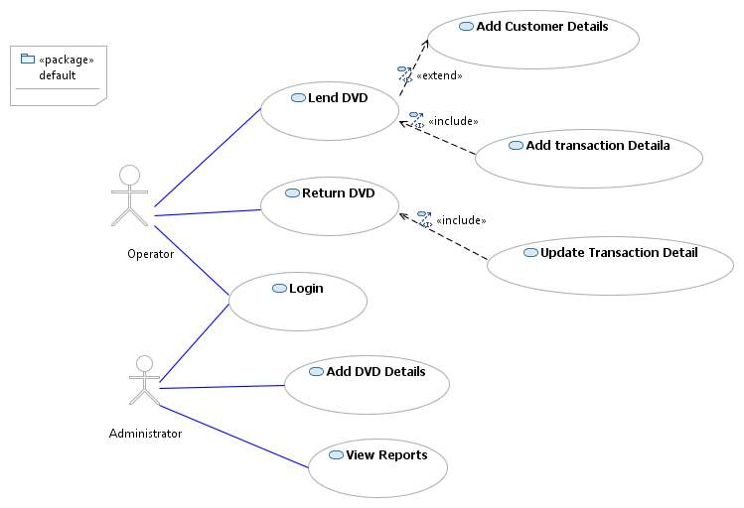

Figure ‑: Use case Diagram

## Prototype of User Interfaces

According the requirements gathered so far, some of the user interface screens were sketched to be verified from

#### The login screen

The login screen will appear when the user starts the system, and cannot proceed without logging in. The user role will be one of “Operator” or “Administrator”.

Depending on the role of the user logged in to the system, the functionalities that are enabled will be different.

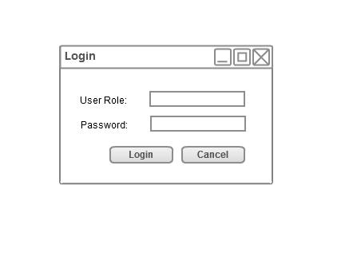

Figure ‑: The Login Screen

#### The Main Screen

After logging in to the system with correct password, the main screen will appear where an operator can perform tasks like adding customer details and lend/return transactions. The main screen will also contain two menus:

* Administrator – to perform administrative tasks.
* Reports – to view reports.

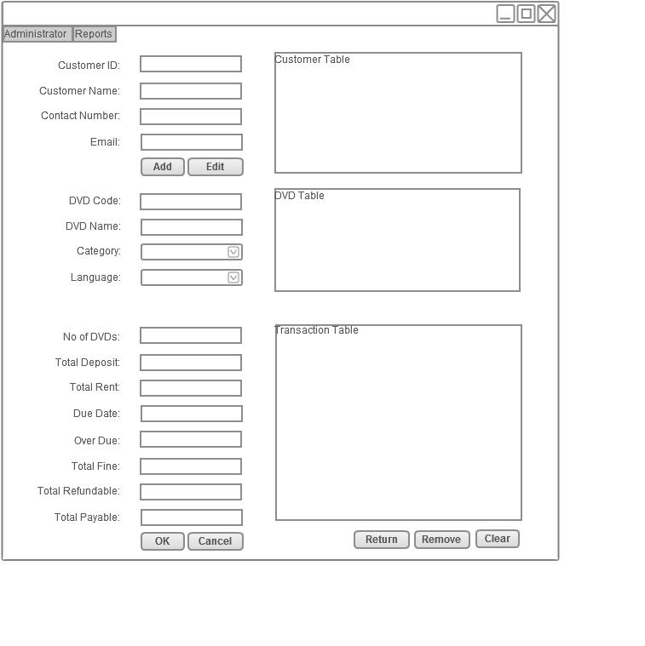

Figure ‑: The Main Screen

#### The DVD screen

The DVD screen will be used to enter stock details to the system and will only be accessible to the user if he/she logged in as an administrator.

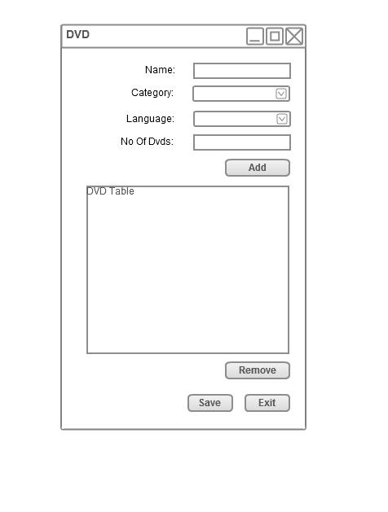

Figure ‑: The DVD Screen

## Detailed requirements specification

Functional Requirements:

1. Data storage requirements – the system should be able to store the following data:
   1. Customer details to be stored are :
      1. Customer Id
      2. Customer Name
      3. Contact Number
      4. Email
   2. DVD details to be stored are :
      1. Code
      2. Name
      3. Language
      4. Category
      5. Number Of Copies
   3. Transaction details to be stored are :
      1. Transaction Id
      2. Customer Id
      3. DVD Code
      4. Date of transaction
      5. Due date
   4. User details to be stored in order to implement security are:
      1. User role
      2. password
2. Calculations – all the transaction related calculations should be automated
   1. Calculating fine – (fine = number of overdue days * fine per day)
   2. Calculating deposit – (deposit = number of DVDs * deposit per DVD)
   3. Calculating rental – (rental = number of DVDs)
   4. Calculating total payable – (total = (rental + fine) – deposit)
3. Information retrieval:
   1. Customer information – should be able to retrieve by giving the customer name.
   2. DVD information – should be able to retrieve by giving DVD name, DVD code or DVD type.
   3. Transaction information - should be able to retrieve by giving the customer name.
   4. User information – should be able to retrieve the user’s password when the user role is given.
4. Report generation:
   1. Daily report – system should be able to generate a report daily containing the following information:
   2. Number of transactions
   3. Net income
   4. Total refundable

Non Functional Requirements:

1. System should implement user access level security – i.e. different users have different levels of access.
   1. There are two identified user access levels
      1. Administrator – should have access to all the functionalities of the system.
      2. Operator – should have access only to:
         1. Transaction data storage and retrieval.
         2. Customer data storage and retrieval.
         3. DVD data retrieval.
2. The system should be user friendly.
3. Should be easy to learn.
4. Should contain helping texts/messages to users.
5. Data storage and retrieval activities should be efficient.

## Requirements confirmation of the New System

Based on the system analysis work carried out, a document was prepared, titled as “Detailed requirements specification for the DVD Renting System at the Southern DVD Canter”.

A copy of this document was sent to Mr. Rathnayaka, the owner of the shop for his approval to continue with the project. Along with this document the use case diagram of the system and the prototypes of the screens were sent. The following page is a copy of the covering letter that was sent to Mr. Rathnayaka.

## Comments on the System Requirements Document by the Customer

The following page is a copy of the note that was received from Mr. Rathnayaka.

# Initial project schedule

|  |  |
| --- | --- |
| Phases | Expected Completion Date |
| Initial Requirements gathering | 14.09.2010 |
| Development of prototype | 07.10.2010 |
| Detailed requirements gathering | 08.11.2010 |
| Documentation of design and test plan | 30.11.2010 |
| Development & Testing | 15.01.2011 |
| Implementation and validation | 31.01.2011 |
| Documentation | 14.02.2011 |

Table 3‑1: Project Milestones

|  |  |  |  |  |  |  |  |  |  |  |  |  |  |  |  |  |  |  |  |  |  |  |  |  |  |
| --- | --- | --- | --- | --- | --- | --- | --- | --- | --- | --- | --- | --- | --- | --- | --- | --- | --- | --- | --- | --- | --- | --- | --- | --- | --- |
|  | September | | | | October | | | | November | | | | December | | | | January | | | | February | | | | |
| Week | 1 | 2 | 3 | 4 | 1 | 2 | 3 | 4 | 1 | 2 | 3 | 4 | 1 | 2 | 3 | 4 | 1 | 2 | 3 | 4 | 1 | 2 | 3 | 4 |
| Tasks |  |  |  |  |  |  |  |  |  |  |  |  |  |  |  |  |  |  |  |  |  |  |  |  |
| Requirements gathering |  |  |  |  |  |  |  |  |  |  |  |  |  |  |  |  |  |  |  |  |  |  |  |  |
|  |  |  |  |  |  |  |  |  |  |  |  |  |  |  |  |  |  |  |  |  |  |  |  |  |
| Prototype Development |  |  |  |  |  |  |  |  |  |  |  |  |  |  |  |  |  |  |  |  |  |  |  |  |
|  |  |  |  |  |  |  |  |  |  |  |  |  |  |  |  |  |  |  |  |  |  |  |  |  |
| Detailed requirements gathering |  |  |  |  |  |  |  |  |  |  |  |  |  |  |  |  |  |  |  |  |  |  |  |  |
|  |  |  |  |  |  |  |  |  |  |  |  |  |  |  |  |  |  |  |  |  |  |  |  |  |
| Design and Test plan |  |  |  |  |  |  |  |  |  |  |  |  |  |  |  |  |  |  |  |  |  |  |  |  |
|  |  |  |  |  |  |  |  |  |  |  |  |  |  |  |  |  |  |  |  |  |  |  |  |  |
| Development & Testing |  |  |  |  |  |  |  |  |  |  |  |  |  |  |  |  |  |  |  |  |  |  |  |  |
|  |  |  |  |  |  |  |  |  |  |  |  |  |  |  |  |  |  |  |  |  |  |  |  |  |
| Implementation and validation |  |  |  |  |  |  |  |  |  |  |  |  |  |  |  |  |  |  |  |  |  |  |  |  |
|  |  |  |  |  |  |  |  |  |  |  |  |  |  |  |  |  |  |  |  |  |  |  |  |  |
| Documentation |  |  |  |  |  |  |  |  |  |  |  |  |  |  |  |  |  |  |  |  |  |  |  |  |

Table 3‑2: Gantt chart

# System Design

There are two appropriate system design methods that could be used in designing the DVD renting system.

* SSADM – Structured System Analysis and Design
* OOAD – Object Oriented System Analysis and Design

OOAD was chosen to design the proposed DVD renting system for the Southern DVD Canter, since object orientation gives more understanding of the system domain objects and it will be very helpful in developing an accurate design of the system. Furthermore object oriented modeling allows more flexibility to system extensions or expansions when need to introduce additional functionalities or doing functionality enhancements. Unified modeling language is used to develop the system models. Object orientation also allows re-usability of functions and therefore increase the productivity.

## System Detailed Design

Since the system is to develop using object orientation, the main domain objects and their relationships have to be identified and modeled. Then the overall architecture of the system or the main components of the system are modeled showing the interaction of the domain objects with other system components.

### Sequence Diagram

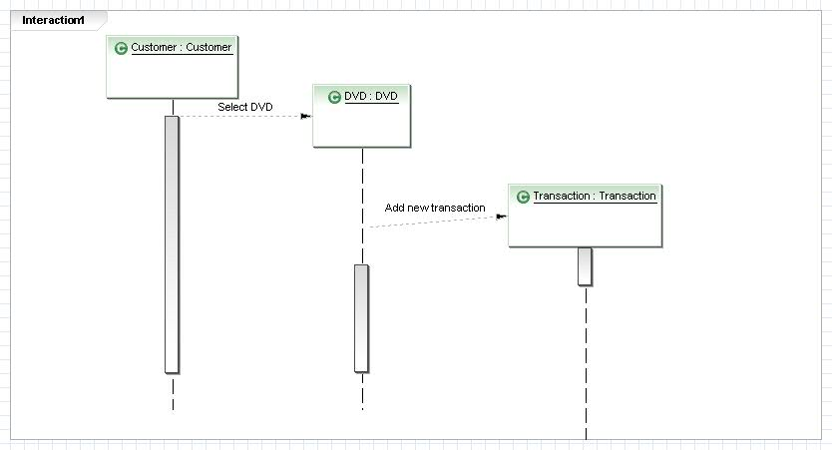

Figure ‑: Sequence diagram

### Data model of the system

While analyzing the business procedures, three main domain objects could be identified; those are, DVD, Transaction and Customer. By analyzing other system requirements there is another object which is of importance which is user. Altogether the system data model consists of four domain objects.

#### Constraints and relationships between domain objects

DVD – a DVD has a number of copies, and therefore can be included in several transactions.

Customer – a customer should have done at least one transaction.

Transaction – a transaction consists of one DVD and one customer.

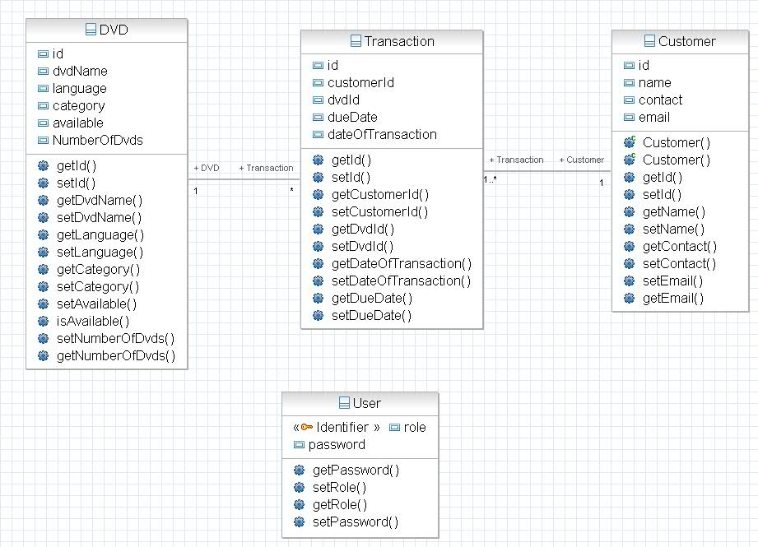

Figure ‑: Class Diagram

### Database Design

There are three main tables for data storage and another table to store user role and password. Details which are required to calculate transaction details like rental amount charged per DVD, deposit amount charged per DVD and number of days user is allowed to keep the DVDs are kept in a property file and retrieved when required.

|  |  |  |  |
| --- | --- | --- | --- |
| Table | Field | Data type | Status |
| customer | Customer Id | Auto number | Primary key |
|  | Customer Name | text |  |
|  | Contact | number |  |
|  | Email | text |  |
| Transaction | Transaction Id | Auto number | Primary Key |
|  | Customer Id | text |  |
|  | DVD code | text |  |
|  | Date of transaction | Date/time |  |
| DVD | DVD code | AutoNumber | Primary key |
|  | DVD Name | text |  |
|  | Language | text |  |
|  | Category | text |  |
|  | Number of copies | number |  |
| User | Role | text | Primary key |
|  | Password | text |  |

Table 4‑1: Data base tables

### User interface Design and Business Logic

The user interfaces and the underlying business logic are designed based on the Model View Controller design pattern. The above mentioned data model (Data classes) represents the ‘Model’, each user interface class represents the ‘View’ while there is ‘Controller’ class to handle the business logic.

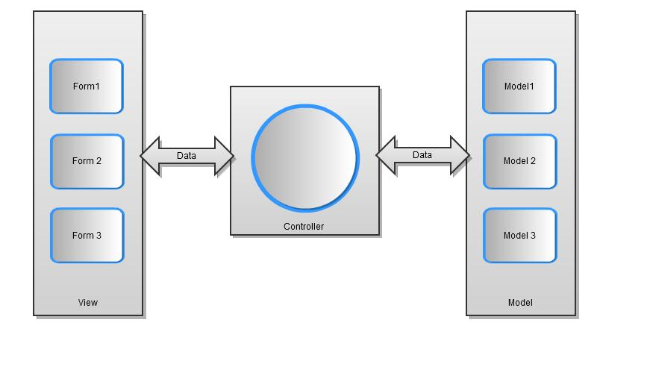

Figure ‑: User interface architecture

#### View

The view consists of user interfaces where the user inputs will be captured and outputs will be presented to the user. User input validations will be handled here.

Login view (Figure 2.3)

The log-in view will be displayed to the user whenever a user starts the application. The user role and the password entered by the user will be validated by comparing the values from database. If the user credentials are authenticated the user will be navigated to the main view, otherwise will show a message

Main view (Figure 2.4)

The main view will contain a menu that provides navigation to the following views:

* The DVD view
* Change password view
* Reports

The main view also provides the following functionalities listed under section 2.12 (Detailed system requirements specification):

* Sub section 1. a
* Sub section 1. c
* All sub sections listed under section 2
* All sub sections listed under section 3

DVD view (Figure 2.5)

The DVD view provides the following functionalities listed under section 2.12 (Detailed system requirements specification):

* Sub section 1. b

Change password view

The change password view can be opened through the menu in the main form. The change password view is used to change the password for a particular user role.

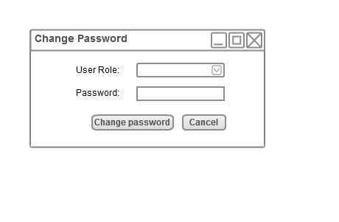

Figure ‑: Change password screen

#### Controller

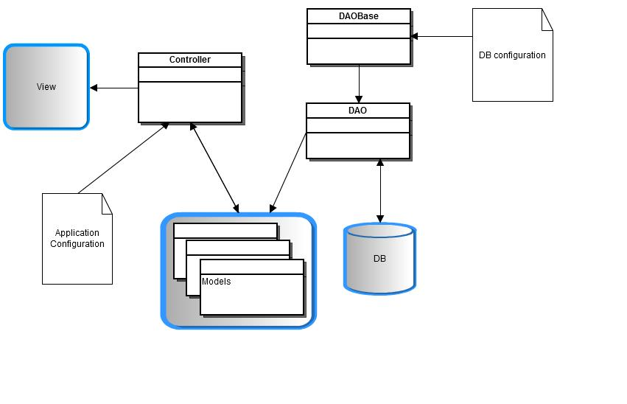The controller take the input data from the view and process the data, execute the commands provided by the user through the user interface and interact with the models to save data in database or retrieve data from database and provide the user with required information. The controller will also communicate with the local file system to get application properties like the rental amount and deposit amount.

Figure ‑: Architecture Diagram of Controller

#### Models

Models represent the data model of the system. These objects will be saved in the database and retrieved as required. The design of the models is given in section 4.1.2.

## Test plan

The system testing is planned to be done at two stages of the system development lifecycle, i.e. unit testing and integration testing will be carried out while developing the system and functional testing will be carried out after the system development.

### Functional/System Testing

Functional testing is done by creating test conditions for use in evaluating the correctness of the application. It is designed to ensure that system requirements are documented in section 2.12. Functional testing is planned to be carried out by black box testing. All the functionalities of the system will be tested against the corresponding requirements.

### Unit testing

Unit testing is carried out in order to check if the particular module or unit of code is working fine. Unit testing is to be performed right after each unit is developed. White box testing, dry running the code will be performed in unit testing.

### Integration testing

Integration testing will be performed once several units are interconnected, to check whether integration is successful.

# Implementation

## Technologies to be used in development

Development of the DVD renting system involve usage of technologies like a high level programming language, a database management system and other CASE tools like an integrated development environment.

Development approaches that could be used:

* Procedural programming - involves sequential programming and less productive.
* Difficult to introduce changes to functionality and to do enhancements due to high coupling of the functions.
* Object oriented programming - increase productivity by enabling re usability. Makes it easy to do introduce changes to one part without breaking other functionalities due to high cohesion and low coupling between objects.
* Formal methodology - involves mathematical specification. Suitable for critical applications

Justification of the choice

Object oriented programming approach was chosen due to all the advantages it has over the other approaches.

### Programming language

Programming languages that could be used

* C++: supports both object oriented programming and a procedural programming, typed language.
* Java: support object oriented programming, typed language.
* VB.Net : supports object oriented programming, typed language.

Justification of the choice

C++ is a good language which has low level support as well but it lacks some great features that java has like the collection framework, annotations support and simple implementation of generics. VB.Net provides good features for designing user interfaces and can be used as a great CASE tool but it also lacks support for annotation configuration and built-in APIs like the Java persistence API and also VB.Net is platform dependent. therefore the programming language chosen to implement the solution is JAVA (version 6.0), since Java is an object-oriented programming language with built-in application programming interface (API)s that can be used to create graphics and user interfaces and that can be used to create desktop applications. Also java is platform independent so that the application developed, can be used in any operating system.

### RDBMS

Databases that could be used:

* Access Database: Microsoft Access is a relational database management system (RDBMS) that is packaged with the Microsoft suite of office products to run under the Microsoft Windows operating system. Microsoft Access does not scale well for large databases or multiple-access, network environments. Microsoft Access is not designed for high volume multi-user environments that allow multiple clients to read, write and perform other operations on shared files at the same time.  (1)[1]
* MYSQL Database: MYSQL is a server level RDBMS that incorporates the industry standard. The client-server interaction of MYSQL is more robust than Microsoft Access and is capable to handle high volume multi-user environments. Also it is platform independent therefore if the customer needs to move the database to a Linux or Unix server there won’t be a problem. MYSQL is distributed both freely and as a licensed commercial product.
* SQL Server Database: Microsoft SQL Server is a server level RDBMS that incorporates the industry standard. The client-server interaction of SQL Server is more robust than Microsoft Access and is capable to handle high volume multi-user environments. But the cost of SQL Server is high. (1)[2]

Justification of the choice

The RDBMS chosen to implement the solution is MYSQL Community Server which is the open source version. MYSQL is a relational database management system that runs as a server providing multi-user access to a number of databases. MYSQL was chosen over MS Access because of the extended capabilities of MYSQL server like the support for client server implementation and multi user access etc… MYSQL server was chosen over SQL server because of the cost of the SQL server.

### Other technologies and APIs Used

* Java Persistence API is used for object relational mapping - the database that has been chosen is a relational database and the application is implemented using object oriented technology, therefore there should be an object-relational mapping in order to effectively communicate with the database.
* hibernate is used as the persistence framework which is an implementation of the Java Persistence API
* Jgoodies forms library was used to implement the graphical user interfaces.

### Development Environment

An integrated development environment is used to do coding. The chosen IDE is Eclipse. Eclipse is a multi-language software development environment comprising an integrated development environment.

Eclipse IDE was chosen for the following reasons:

* It is an open source IDE
* It is used to develop applications in Java.
* It helps to maintain code quality and also provide support for coding and debugging.
* It also includes some valuable features like code refactoring

## Program listings

### Implementation and Program listings of the views

#### Login View

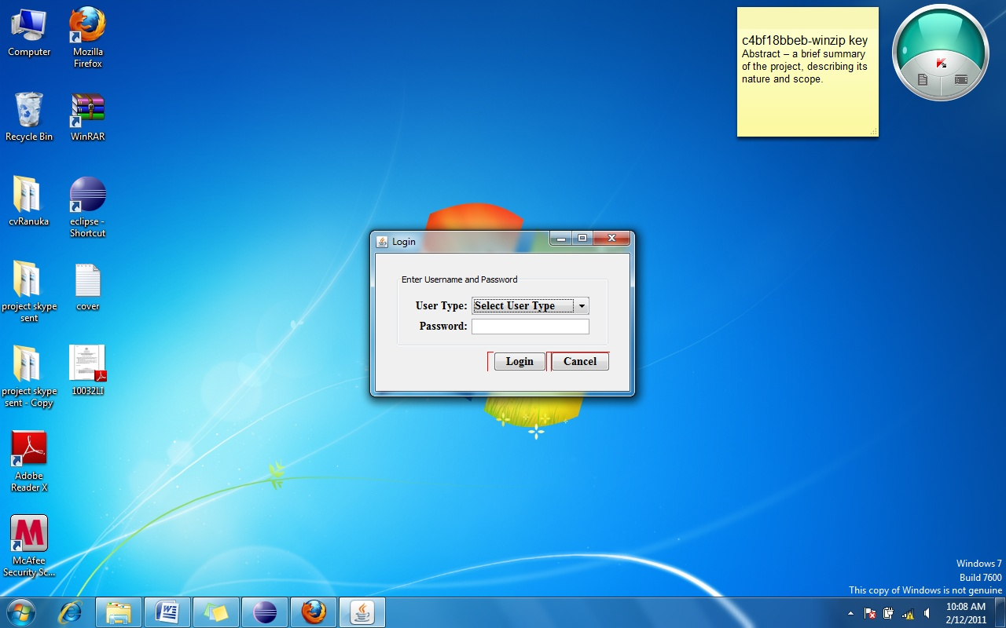

Figure ‑: Login View

package com.dvd.renter.gui;

import java.awt.Dimension;

import java.awt.Font;

import java.awt.Toolkit;

import java.io.IOException;

import javax.swing.*;

import com.dvd.renter.controller.EventController;

import com.dvd.renter.gui.componant.CustomJButton;

import com.dvd.renter.gui.componant.Label;

import com.dvd.renter.util.GuiUtil;

import com.jgoodies.forms.*;

public class LoginForm extends JFrame {

private static final long serialVersionUID = 1L;

protected JComboBox cmbUserRole;

protected JPasswordField txtPassword;

protected Label lblUserName;

protected Label lblPassword;

protected JButton btnLogin;

protected JButton btnCancel;

private EventController controller;

Font font = Font.decode("Times New Roman-bold-14");

public void initComponants() throws IOException {

setDefaultCloseOperation(DISPOSE_ON_CLOSE);

txtPassword = new JPasswordField();

lblPassword = new Label("Password:");

lblUserName = new Label("User Type:");

btnLogin = new CustomJButton("Login", controller);

btnCancel = new CustomJButton("Cancel", controller);

cmbUserRole = new JComboBox(GuiUtil.getComboBoxData("user_roles"));

cmbUserRole.insertItemAt("Select User Type", 0);

cmbUserRole.setSelectedIndex(0);

cmbUserRole.setFont(font);

}

public JPanel createLoginPanel() {

JPanel panel = new JPanel();

DefaultFormBuilder builder = new DefaultFormBuilder(new FormLayout(""));

builder.appendColumn("right:pref");

builder.appendColumn("3dlu");

builder.appendColumn("fill:max(pref; 150px)");

builder.append(lblUserName, cmbUserRole);

builder.nextLine();

builder.append(lblPassword, txtPassword);

builder.nextLine();

panel = builder.getPanel();

Border border = BorderFactory.createCompoundBorder(BorderFactory

.createTitledBorder("Enter Username and Password"),

BorderFactory.createEmptyBorder(10, 20, 10, 20));

panel.setBorder(border);

panel.getBorder().getBorderInsets(panel).set(90, 20, 20, 20);

return panel;

}

public LoginForm(EventController param_controller) throws IOException {

controller = param_controller;

initComponants();

}

private JPanel createLoginBtnPanel() {

ButtonBarBuilder btnBuilder = new ButtonBarBuilder(new FormDebugPanel());

btnBuilder.setAlignment(CellConstraints.RIGHT, null);

btnBuilder.addGriddedButtons(new JButton[] { btnLogin, btnCancel });

return btnBuilder.getPanel();

}

public void createAndShow() {

this.setTitle("Login");

DefaultFormBuilder builder = new DefaultFormBuilder(new FormLayout(""));

JPanel panel = new JPanel();

builder.setBorder(BorderFactory.createEmptyBorder(20, 20, 20, 20));

builder.appendColumn("right:pref");

builder.append(createLoginPanel());

builder.nextLine();

builder.append(createLoginBtnPanel());

panel.add(builder.getPanel());

add(panel);

pack();

// Get the size of the screen

Dimension dim = Toolkit.getDefaultToolkit().getScreenSize();

// Determine the new location of the window

int w = getSize().width;

int h = getSize().height;

int x = (dim.width - w) / 2;

int y = (dim.height - h) / 2;

// Move the window

setLocation(x, y);

setVisible(true);

}

public EventController getController() {

return controller;

}

public void setController(EventController param_controller) {

controller = param_controller;

}}

#### Main View

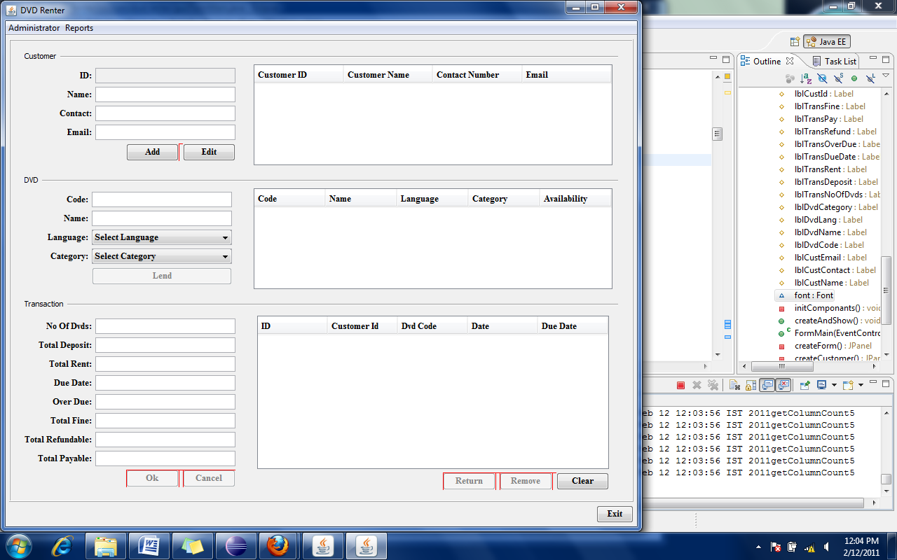

Figure ‑: Main View

package com.dvd.renter.gui;

import java.awt.BorderLayout;

import java.awt.Dimension;

import java.awt.Font;

import java.io.IOException;

import javax.swing.*;

import org.apache.log4j.Logger;

import com.dvd.renter.controller.EventController;

import com.dvd.renter.entity.Customer;

import com.dvd.renter.entity.DVD;

import com.dvd.renter.entity.Transaction;

import com.dvd.renter.gui.componant.*;

import com.dvd.renter.util.GuiUtil;

import com.gui.generictablemodel.GenericTableModel;

import com.jgoodies.forms.*;

public class FormMain extends JPanel {

private static final long serialVersionUID = 1L;

private static final Logger LOGGER = Logger.getLogger(FormMain.class);

private EventController con;

protected JMenuBar menuBar;

protected JMenu adminMenu;

protected JMenu reportsMenu;

protected JMenu dvdSubmenu;

protected JMenuItem dvdMenuItem;

protected JMenuItem usersMenuItem;

protected JMenuItem loginMenuItem;

protected JMenuItem dailyReportMenuItem;

protected JTextField txtCustId;

protected JTextField txtCustName;

protected JTextField txtContact;

protected JTextField txtEmail;

protected JTextField txtDvdId;

protected JTextField txtDvdName;

protected JTextField txtDueDate;

protected JTextField txtLentDate;

protected JTextField txtDeposit;

protected JTextField txtTotalPay;

protected JTextField txtTotalFine;

protected JTextField txtOverDueDays;

protected JTextField txtNoOfDvds;

protected JTextField txtRefundable;

protected JTextField txtRent;

protected JComboBox cmbDvdCategory;

protected JComboBox cmbDVDLanguage;

protected JButton btnEditCustomer;

protected JButton btnAddCustomer;

protected JButton btnAddtoTransaction;

protected JButton btnLend;

protected JButton btnReturn;

protected JButton btnClear;

protected JButton btnRemoveTransaction;

protected JButton btnExit;

protected JButton btnOk;

protected JButton btnCancel;

protected JTable tblCustomer;

protected JTable tblDvd;

protected JTable tblTransaction;

protected GenericTableModel<Customer> customerTableModel;

protected GenericTableModel<DVD> dvdTableModel;

protected GenericTableModel<Transaction> transactinTblModel;

protected Label lblCustId;

protected Label lblTransFine;

protected Label lblTransPay;

protected Label lblTransRefund;

protected Label lblTransOverDue;

protected Label lblTransDueDate;

protected Label lblTransRent;

protected Label lblTransDeposit;

protected Label lblTransNoOfDvds;

protected Label lblDvdCategory;

protected Label lblDvdLang;

protected Label lblDvdName;

protected Label lblDvdCode;

protected Label lblCustEmail;

protected Label lblCustContact;

protected Label lblCustName;

Font font = Font.decode("Times New Roman-bold-14");

private void initComponants() throws IOException {

menuBar = new JMenuBar();

adminMenu = new JMenu("Administrator");

dvdMenuItem = new JMenuItem("Inventory");

dvdMenuItem.addActionListener(con);

usersMenuItem = new JMenuItem("User Profiles");

usersMenuItem.addActionListener(con);

adminMenu.add(dvdMenuItem);

adminMenu.add(usersMenuItem);

menuBar.add(adminMenu);

reportsMenu = new JMenu("Reports");

dailyReportMenuItem = new JMenuItem("View Daily Report");

reportsMenu.add(dailyReportMenuItem);

menuBar.add(reportsMenu);

loginMenuItem = new JMenuItem("Login");

loginMenuItem.addActionListener(con);

adminMenu.add(loginMenuItem);

lblCustContact = new Label("Contact:");

lblCustEmail = new Label("Email:");

lblCustId = new Label("ID:");

lblCustName = new Label("Name:");

lblDvdCategory = new Label("Category:");

lblDvdCode = new Label("Code:");

lblDvdLang = new Label("Language:");

lblDvdName = new Label("Name:");

lblTransDeposit = new Label("Total Deposit:");

lblTransDueDate = new Label("Due Date:");

lblTransFine = new Label("Total Fine:");

lblTransNoOfDvds = new Label("No Of Dvds:");

lblTransOverDue = new Label("Over Due:");

lblTransPay = new Label("Total Payable:");

lblTransRefund = new Label("Total Refundable:");

lblTransRent = new Label("Total Rent:");

txtCustId = new TextField();

txtCustId.setEditable(false);

txtCustName = new TextField();

txtCustName.getDocument().addDocumentListener(con);

txtContact = new TextField();

txtEmail = new TextField();

txtDvdId = new TextField();

txtDvdId.getDocument().addDocumentListener(con);

txtDvdName = new TextField();

txtDvdName.getDocument().addDocumentListener(con);

cmbDvdCategory = new JComboBox(GuiUtil.getComboBoxData("categories"));

cmbDvdCategory.insertItemAt("Select Category", 0);

cmbDvdCategory.setSelectedIndex(0);

cmbDvdCategory.setFont(font);

cmbDvdCategory.addItemListener(con);

cmbDVDLanguage = new JComboBox(GuiUtil.getComboBoxData("languages"));

cmbDVDLanguage.insertItemAt("Select Language", 0);

cmbDVDLanguage.setSelectedIndex(0);

cmbDVDLanguage.setFont(font);

cmbDVDLanguage.addItemListener(con);

txtDueDate = new TextField();

txtLentDate = new TextField();

txtDeposit = new TextField();

txtTotalPay = new TextField();

txtTotalFine = new TextField();

txtOverDueDays = new TextField();

txtNoOfDvds = new TextField();

txtRent = new TextField();

txtRefundable = new TextField();

btnEditCustomer = new CustomJButton("Edit", con);

btnEditCustomer.setToolTipText("Edit customer details");

btnAddCustomer = new CustomJButton("Add", con);

btnAddCustomer.setToolTipText("Add new customer to the system");

btnAddtoTransaction = new CustomJButton("Lend", con);

btnAddtoTransaction.setEnabled(false);

btnAddtoTransaction

.setToolTipText("Add this DVD to the Transaction table");

btnLend = new CustomJButton("Lend", con);

btnReturn = new CustomJButton("Return", con);

btnReturn.setEnabled(false);

btnClear = new CustomJButton("Clear", con);

btnRemoveTransaction = new CustomJButton("Remove", con);

btnRemoveTransaction.setEnabled(false);

btnExit = new CustomJButton("Exit", con);

btnOk = new CustomJButton("Ok", con);

btnOk.setEnabled(false);

btnCancel = new CustomJButton("Cancel", con);

btnCancel.setEnabled(false);

btnCancel.setToolTipText("Cancel transaction");

customerTableModel = new GenericTableModel<Customer>(new Customer());

dvdTableModel = new com.gui.generictablemodel.GenericTableModel<DVD>(

new DVD());

transactinTblModel = new GenericTableModel<Transaction>(

new Transaction());

transactinTblModel.addTableModelListener(con);

tblCustomer = new Table(customerTableModel);

tblCustomer.setName(Customer.class.getName());

tblDvd = new Table(dvdTableModel);

tblDvd.setName(DVD.class.getName());

tblTransaction = new Table(transactinTblModel);

tblTransaction.setName(Transaction.class.getName());

}

public void createAndShow() {

JFrame frame = new JFrame("DVD Renter");

frame.setJMenuBar(menuBar);

frame.add(this);

frame.setDefaultCloseOperation(JFrame.EXIT_ON_CLOSE);

frame.pack();

frame.setVisible(true);

}

public FormMain(EventController contr) throws IOException {

super(new BorderLayout());

con = contr;

initComponants();

DefaultFormBuilder builder = new DefaultFormBuilder(new FormLayout(""));

builder.appendColumn("right:pref");

builder.append(createForm());

builder.nextLine();

builder.append(btnExit);

JPanel panel = new JPanel();

panel.setBorder(new EmptyBorder(10, 10, 5, 10));

panel.add(builder.getPanel());

add(panel);

}

private JPanel createForm() {

DefaultFormBuilder builder = new DefaultFormBuilder(new FormLayout(""));

Border border = BorderFactory.createCompoundBorder(BorderFactory

.createEtchedBorder(EtchedBorder.RAISED), new EmptyBorder(15,

20, 10, 20));

builder.setBorder(border);

builder.appendColumn("right:pref");

builder.appendColumn("17dlu");

builder.appendColumn("fill:max(pref; 150px)");

builder.appendColumn("5dlu");

builder.appendColumn("right:pref");

tblCustomer.setPreferredScrollableViewportSize(new Dimension(500, 115));

tblCustomer.addMouseListener(con);

JScrollPane custScrollPane = new JScrollPane(tblCustomer);

tblCustomer.setFillsViewportHeight(true);

tblDvd.setPreferredScrollableViewportSize(new Dimension(500, 115));

tblDvd.addMouseListener(con);

JScrollPane dvdScrollPane = new JScrollPane(tblDvd);

tblDvd.setFillsViewportHeight(true);

builder.appendSeparator("Customer");

builder.append(createCustomer(), custScrollPane);

builder.nextLine();

builder.appendSeparator("DVD");

builder.append(createDvd(), dvdScrollPane);

builder.nextLine();

builder.appendSeparator("Transaction");

builder.append(createTransaction(), createTransactionTable());

builder.nextLine();

return builder.getPanel();

}

private JPanel createCustomer() {

DefaultFormBuilder builder = new DefaultFormBuilder(new FormLayout(""));

// builder.setBorder(BorderFactory.createEmptyBorder(5, 5, 5, 5));

builder.appendColumn("right:pref");

builder.appendColumn("3dlu");

builder.appendColumn("fill:max(pref; 200px)");

builder.append(lblCustId, txtCustId);

builder.nextLine();

builder.append(lblCustName, txtCustName);

builder.nextLine();

builder.append(lblCustContact, txtContact);

builder.nextLine();

builder.append(lblCustEmail, txtEmail);

builder.nextLine();

ButtonBarBuilder btnBuilder = new ButtonBarBuilder(new FormDebugPanel());

btnBuilder.addGriddedButtons(new JButton[] { btnAddCustomer,

btnEditCustomer });

DefaultFormBuilder outBuilder = new DefaultFormBuilder(new FormLayout(

""));

outBuilder.appendColumn("right:pref");

outBuilder.append(builder.getPanel());

outBuilder.append(btnBuilder.getPanel());

return outBuilder.getPanel();

}

private JPanel createDvd() {

DefaultFormBuilder builder = new DefaultFormBuilder(new FormLayout(""));

builder.setBorder(BorderFactory.createEmptyBorder(5, 5, 5, 5));

builder.appendColumn("right:pref");

builder.appendColumn("3dlu");

builder.appendColumn("fill:max(pref; 200px)");

builder.append(lblDvdCode, txtDvdId);

builder.nextLine();

builder.append(lblDvdName, txtDvdName);

builder.nextLine();

builder.append(lblDvdLang, cmbDVDLanguage);

builder.nextLine();

builder.append(lblDvdCategory, cmbDvdCategory);

builder.nextLine();

builder.append("", btnAddtoTransaction);

return builder.getPanel();

}

private JPanel createTransaction() {

DefaultFormBuilder builder = new DefaultFormBuilder(new FormLayout(""));

builder.appendColumn("right:pref");

builder.appendColumn("3dlu");

builder.appendColumn("fill:max(pref; 200px)");

builder.append(lblTransNoOfDvds, txtNoOfDvds);

builder.nextLine();

builder.append(lblTransDeposit, txtDeposit);

builder.nextLine();

builder.append(lblTransRent, txtRent);

builder.nextLine();

builder.append(lblTransDueDate, txtDueDate);

builder.nextLine();

builder.append(lblTransOverDue, txtOverDueDays);

builder.nextLine();

builder.append(lblTransFine, txtTotalFine);

builder.nextLine();

builder.append(lblTransRefund, txtRefundable);

builder.nextLine();

builder.append(lblTransPay, txtTotalPay);

builder.nextLine();

ButtonBarBuilder btnBuilder = new ButtonBarBuilder(new FormDebugPanel());

btnBuilder.addGriddedButtons(new JButton[] { btnOk, btnCancel });

DefaultFormBuilder outBuilder = new DefaultFormBuilder(new FormLayout(

""));

outBuilder.appendColumn("right:pref");

outBuilder.append(builder.getPanel());

outBuilder.append(btnBuilder.getPanel());

return outBuilder.getPanel();

}

private JPanel createTransactionTable() {

DefaultFormBuilder builder = new DefaultFormBuilder(new FormLayout(""));

builder.setBorder(BorderFactory.createEmptyBorder(5, 5, 5, 5));

builder.appendColumn("right:pref");

tblTransaction.setPreferredScrollableViewportSize(new Dimension(500,

190));

tblTransaction.addMouseListener(con);

JScrollPane transacScrollPane = new JScrollPane(tblTransaction);

tblTransaction.setFillsViewportHeight(true);

ButtonBarBuilder btnBuilder = new ButtonBarBuilder(new FormDebugPanel());

btnBuilder.addGriddedButtons(new JButton[] { btnReturn,

btnRemoveTransaction, btnClear });

builder.append(transacScrollPane);

builder.nextLine();

builder.append(btnBuilder.getPanel());

return builder.getPanel();

}

public EventController getCon() {

return con;

}

public void setCon(EventController param_con) {

con = param_con;

}}

#### DVD View

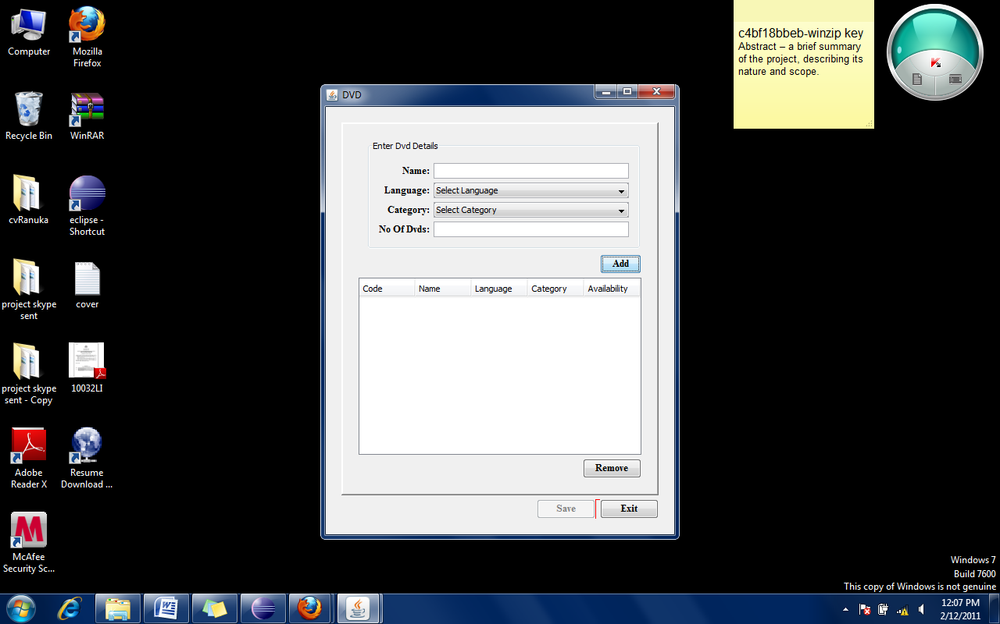

Figure ‑: DVD view

package com.dvd.renter.gui;

import java.awt.Dimension;

import java.awt.Toolkit;

import java.io.IOException;

import javax.swing.*;

import com.dvd.renter.controller.EventController;

import com.dvd.renter.entity.DVD;

import com.dvd.renter.gui.componant.CustomJButton;

import com.dvd.renter.gui.componant.Label;

import com.dvd.renter.util.GuiUtil;

import com.gui.generictablemodel.GenericTableModel;

import com.jgoodies.forms.*;

public class DvdForm extends JFrame {

private static final long serialVersionUID = 1L;

protected JTextField txtDvdId;

protected JTextField txtDvdName;

protected JTextField txtNoOfDvds;

protected JComboBox cmbDvdCategory;

protected JComboBox cmbDVDLanguage;

protected Label lblDvdCategory;

protected Label lblDvdLang;

protected Label lblDvdName;

protected Label lblDvdCode;

protected EventController controller;

protected JButton btnAdd;

protected JButton btnCancel;

protected JButton btnRemove;

protected JButton btnSave;

protected JTable tblDvd;

protected GenericTableModel<DVD> dvdTableModel;

protected Label lblTransNoOfDvds;

private void init() throws IOException {

lblDvdCategory = new Label("Category:");

lblDvdCode = new Label("Code:");

lblDvdLang = new Label("Language:");

lblDvdName = new Label("Name:");

lblTransNoOfDvds = new Label("No Of Dvds:");

txtDvdId = new JTextField();

txtDvdName = new JTextField();

txtNoOfDvds = new JTextField();

cmbDvdCategory = new JComboBox(GuiUtil.getComboBoxData("categories"));

cmbDvdCategory.insertItemAt("Select Category", 0);

cmbDvdCategory.setSelectedIndex(0);

cmbDvdCategory.addItemListener(controller);

cmbDVDLanguage = new JComboBox(GuiUtil.getComboBoxData("languages"));

cmbDVDLanguage.insertItemAt("Select Language", 0);

cmbDVDLanguage.setSelectedIndex(0);

cmbDVDLanguage.addItemListener(controller);

btnAdd = new CustomJButton("Add", controller);

btnCancel = new CustomJButton("Exit", controller);

btnRemove = new CustomJButton("Remove", controller);

btnSave = new CustomJButton("Save", controller);

btnSave.setEnabled(false);

dvdTableModel = new com.gui.generictablemodel.GenericTableModel<DVD>(

new DVD());

tblDvd = new JTable(dvdTableModel);

tblDvd.setName(DVD.class.getName());

}

private JPanel createDvdFrame() {

DefaultFormBuilder builder = new DefaultFormBuilder(new FormLayout(""));

Border border = BorderFactory.createCompoundBorder(BorderFactory

.createRaisedBevelBorder(), new EmptyBorder(20, 20, 20, 20));

builder.setBorder(border);

builder.appendColumn("right:pref");

builder.append(createDvdForm());

builder.nextLine();

builder.append(btnAdd);

builder.nextLine();

builder.append(createDvdTable());

builder.nextLine();

builder.append(btnRemove);

return builder.getPanel();

}

private JPanel createDvdForm() {

DefaultFormBuilder builder = new DefaultFormBuilder(new FormLayout(""));

builder.setBorder(BorderFactory.createCompoundBorder(new TitledBorder(

"Enter Dvd Details"), BorderFactory.createEmptyBorder(10, 10,

10, 10)));

builder.appendColumn("right:pref");

builder.appendColumn("3dlu");

builder.appendColumn("fill:max(pref; 250px)");

builder.append(lblDvdName, txtDvdName);

builder.nextLine();

builder.append(lblDvdLang, cmbDVDLanguage);

builder.nextLine();

builder.append(lblDvdCategory, cmbDvdCategory);

builder.nextLine();

builder.append(lblTransNoOfDvds, txtNoOfDvds);

builder.nextLine();

return builder.getPanel();

}

private JScrollPane createDvdTable() {

tblDvd.setPreferredScrollableViewportSize(new Dimension(360, 200));

tblDvd.addMouseListener(controller);

JScrollPane dvdScrollPane = new JScrollPane(tblDvd);

tblDvd.setFillsViewportHeight(true);

return dvdScrollPane;

}

public void run() {

try {

UIManager

.setLookAndFeel("com.sun.java.swing.plaf.windows.WindowsLookAndFeel");

} catch (ClassNotFoundException e) {

e.printStackTrace();

} catch (InstantiationException e) {

e.printStackTrace();

} catch (IllegalAccessException e) {

e.printStackTrace();

} catch (UnsupportedLookAndFeelException e) {

e.printStackTrace();

}

try {

init();

} catch (IOException e) {

e.printStackTrace();

}

setTitle("DVD");

DefaultFormBuilder builder = new DefaultFormBuilder(new FormLayout(""));

builder.setBorder(new EmptyBorder(20, 20, 20, 20));

builder.appendColumn("right:pref");

ButtonBarBuilder btnBuilder = new ButtonBarBuilder(new FormDebugPanel());

btnBuilder.addGriddedButtons(new JButton[] { btnSave, btnCancel });

builder.append(createDvdFrame());

builder.nextLine();

builder.append(btnBuilder.getPanel());

add(builder.getPanel());

pack();

// Get the size of the screen

Dimension dim = Toolkit.getDefaultToolkit().getScreenSize();

// Determine the new location of the window

int w = getSize().width;

int h = getSize().height;

int x = (dim.width - w) / 2;

int y = (dim.height - h) / 2;

// Move the window

setLocation(x, y);

setVisible(true);

}

public void setController(EventController eventController) {

this.controller = eventController;

}}

### Program listings of the Controller component

#### The controller class

**package** com.dvd.renter.gui;

**import** java.awt.*;

**import** java.io.IOException;

**import** java.math.BigInteger;

**import** java.security.MessageDigest;

**import** java.security.NoSuchAlgorithmException;

**import** java.text.DateFormat;

**import** java.util.*;

**import** javax.swing.*;

**import** org.apache.log4j.Logger;

**import** com.dvd.renter.config.ApplicationProerties;

**import** com.dvd.renter.controller.EventController;

**import** com.dvd.renter.dao.DAO;

**import** com.dvd.renter.dao.DAOBase;

**import** com.dvd.renter.entity.*;

**public** **class** Controller {

**private** **static** **final** String *USER_ROLE_ADMIN* = "Admin";

**private** **static** **final** String *USER_OPERATOR* = "operator";

**private** **static** Logger *LOGGER* = Logger.*getLogger*(Controller.**class**);

**private** **static** Controller *controllerInstance*;

**private** MainGuiForm mainForm;

**private** FormMain formMain;

**private** DAOBase daoBase;

**private** DAO dao;

**private** String userRole;

**private** DVD selectedDvd = **null**;

**private** Customer selectedCustomer = **null**;

**private** GregorianCalendar calander = **new** GregorianCalendar();

**private** Date today = **new** Date();

**private** **int** deposit;

**private** **int** rental;

**private** **boolean** dvdTableChanged = **false**;

**private** **boolean** dvdCodeCanged = **false**;

**private** **boolean** dvdNameCanged = **false**;

**private** **boolean** customerTableClicked = **false**;

**private** DvdForm dvdForm;

**private** LoginForm login;

**private** UserForm userForm;

{

daoBase = **new** DAOBase();

dao = **new** DAO(daoBase);

**try** {

deposit = Integer.*parseInt*(ApplicationProerties

.*getProperty*("deposit"));

rental = Integer.*parseInt*(ApplicationProerties

.*getProperty*("rental"));

calander.add(GregorianCalendar.*DATE*, Integer

.*parseInt*(ApplicationProerties.*getProperty*("days")));

} **catch** (NumberFormatException e) {

*LOGGER*.error("Invalid deposit value in Application Properties", e);

System.*exit*(0);

} **catch** (IOException e) {

*LOGGER*.error("Could not read Application properties", e);

System.*exit*(0);

}

}

/**

* If the <code>controllerInstance</code> is null creates a new instance of

* the <code>Controller</code>.

*

* **@return** the <code>controllerInstance</code>

*/

**public** **static** Controller getControllerInstance() {

*controllerInstance* = **new** Controller();

**if** (*controllerInstance* == **null**) {

}

**return** *controllerInstance*;

}

/**

* The constructor has been made private in order to make the Controller,

* Singleton.

*

*/

**private** Controller() {

}

**public** **void** txtChanged(DocumentEvent e) {

**if** (e.getDocument() == formMain.txtCustName.getDocument()) {

txtCutomerNameChanged();

} **else** **if** (e.getDocument() == formMain.txtDvdName.getDocument()) {

txtDvdNameChanged();

} **else** **if** (e.getDocument() == formMain.txtDvdId.getDocument()) {

txtDvdCodeChanged();

}

}

**private** **void** txtDvdCodeChanged() {

String dvdCode = formMain.txtDvdId.getText();

**if** (dvdCode.trim().matches("([0-9]*)")) {

**if** (!dvdCode.isEmpty() && !dvdTableChanged && !dvdNameCanged) {

Vector<DVD> dvds = **new** Vector<DVD>();

dvdCodeCanged = **true**;

List<DVD> dvdLst = dao.findByCode(Integer.*parseInt*(dvdCode));

dvds.addAll(dvdLst);

**for** (DVD dvd : dvdLst) {

**if** (dvd.getNumberOfDvds() > 0) {

dvd.setAvailable(**true**);

} **else**

dvd.setAvailable(**false**);

}

formMain.dvdTableModel.setDataVector(dvds);

formMain.dvdTableModel.fireTableDataChanged();

formMain.cmbDvdCategory.setSelectedIndex(0);

formMain.cmbDVDLanguage.setSelectedIndex(0);

formMain.txtDvdName.setText("");

dvdCodeCanged = **false**;

}

} **else** {

JOptionPane.*showMessageDialog*(**null**, "Please enter valid DVD code",

"Invalid DVD Code!", JOptionPane.*ERROR_MESSAGE*);

formMain.txtDvdId.selectAll();

**return**;

}

}

**private** **void** txtDvdNameChanged() {

**if** (!dvdTableChanged && !dvdCodeCanged) {

dvdNameCanged = **true**;

formMain.txtDvdId.setText("");

formMain.cmbDvdCategory.setSelectedIndex(0);

formMain.cmbDVDLanguage.setSelectedIndex(0);

Vector<DVD> dvds = **new** Vector<DVD>();

dvds.addAll(dao.findEntityByName(formMain.txtDvdName.getText(),

DVD.**class**));

formMain.dvdTableModel.setDataVector(dvds);

formMain.dvdTableModel.fireTableDataChanged();

dvdNameCanged = **false**;

}

}

**private** **void** txtCutomerNameChanged() {

**if** (!customerTableClicked) {

**if** (!formMain.transactinTblModel.getDataVector().isEmpty()) {

formMain.transactinTblModel.getDataVector().clear();

formMain.transactinTblModel.fireTableDataChanged();

}

*LOGGER*.debug("txtName: " + formMain.txtCustName.getText());

Vector<Customer> cs = **new** Vector<Customer>();

cs.addAll(dao.findEntityByName(formMain.txtCustName.getText(),

Customer.**class**));

*LOGGER*.debug("query result for '" + formMain.txtCustName.getText()

+ "': " + cs.toString());

formMain.txtContact.setText("");

formMain.txtCustId.setText("");

formMain.txtEmail.setText("");

formMain.customerTableModel.setDataVector(cs);

formMain.customerTableModel.fireTableDataChanged();

}

}

**private** **void** setCustomerFields(Customer customer) {

formMain.txtCustName.setText(customer.getName());

formMain.txtCustId.setText(String.*valueOf*(customer.getId()));

formMain.txtContact.setText(customer.getContact());

formMain.txtEmail.setText(customer.getEmail());

}

**public** **void** customerTableClicked() {

**int** row = formMain.tblCustomer.getSelectedRow();

**if** (row > -1) {

customerTableClicked = **true**;

selectedCustomer = **new** Customer();

selectedCustomer = formMain.customerTableModel.getDataVector().get(

row);

*LOGGER*.debug("selected row customer id: "

+ selectedCustomer.getId());

setCustomerFields(selectedCustomer);

formMain.customerTableModel.getDataVector().clear();

formMain.customerTableModel.getDataVector().add(selectedCustomer);

formMain.customerTableModel.fireTableDataChanged();

List<Transaction> transactionLst = dao

.findTransactionByCustomer(selectedCustomer);

**if** (!transactionLst.isEmpty()) {

Vector<Transaction> transactions = **new** Vector<Transaction>();

transactions.addAll(transactionLst);

formMain.transactinTblModel.setDataVector(transactions);

formMain.transactinTblModel.fireTableDataChanged();

formMain.txtOverDueDays.setEnabled(**false**);

formMain.txtRefundable.setEnabled(**false**);

}

customerTableClicked = **false**;

**if** (selectedDvd != **null**

&& formMain.tblTransaction.getRowCount() == 0) {

formMain.btnAddtoTransaction.setEnabled(**true**);

}

}

}

**public** **void** dvdTableClicked() {

*LOGGER*.debug("Dvd table clicked");

**int** row = formMain.tblDvd.getSelectedRow();

**if** (row > -1) {

dvdTableChanged = **true**;

selectedDvd = formMain.dvdTableModel.getDataVector().get(row);

formMain.txtDvdName.setText(selectedDvd.getDvdName());

formMain.txtDvdId.setText(String.*valueOf*(selectedDvd.getId()));

formMain.cmbDvdCategory.setSelectedItem(selectedDvd.getCategory());

formMain.cmbDVDLanguage.setSelectedItem(selectedDvd.getLanguage());

dvdTableChanged = **false**;

**if** (selectedCustomer != **null**

&& formMain.tblTransaction.getRowCount() == 0) {

formMain.btnAddtoTransaction.setEnabled(**true**);

}

}

}

**public** **void** btnPressedFormMain(ActionEvent e) **throws** NumberFormatException,

IOException, NoSuchAlgorithmException {

**if** (e.getSource() == formMain.btnAddCustomer) {

*LOGGER*.debug("add pressed");

addCustomer();

} **else** **if** (e.getSource() == formMain.btnAddtoTransaction) {

**if** (selectedDvd != **null** && selectedCustomer != **null**) {

addTransaction();

}

} **else** **if** (e.getSource() == formMain.btnLend) {

**if** (!formMain.transactinTblModel.getDataVector().isEmpty()) {

**for** (Transaction transaction : formMain.transactinTblModel

.getDataVector()) {

dao.addEntity(transaction);

}

}

} **else** **if** (e.getSource() == formMain.btnRemoveTransaction) {

**int** selectedIndex = formMain.tblTransaction.getSelectedRow();

formMain.transactinTblModel.getDataVector().removeElementAt(

selectedIndex);

formMain.transactinTblModel.fireTableDataChanged();

} **else** **if** (e.getSource() == formMain.btnReturn) {

**for** (Transaction transaction : formMain.transactinTblModel

.getDataVector()) {

dao.removeEntity(transaction);

}

} **else** **if** (e.getSource() == formMain.btnOk) {

saveTransaction();

clearTxt(**new** JTextField[] { formMain.txtContact,

formMain.txtCustId, formMain.txtCustName, formMain.txtEmail });

} **else** **if** (e.getSource() == formMain.btnExit) {

System.*exit*(0);

}

}

**private** **void** clearTxt(JTextField[] param_jTextFields) {

**for** (JTextField jTextField : param_jTextFields) {

jTextField.setText("");

}

}

**public** **void** btnPressedDvdForm(ActionEvent e) {

**if** (e.getSource() == dvdForm.btnAdd) {

addDvd();

} **else** **if** (e.getSource() == dvdForm.btnSave) {

saveDvds();

} **else** **if** (e.getSource() == dvdForm.btnCancel) {

cancel(dvdForm);

} **else** **if** (e.getSource() == dvdForm.btnRemove) {

removeDvd();

}

}

**private** **void** removeDvd() {

dvdForm.dvdTableModel.getDataVector().remove(

dvdForm.tblDvd.getSelectedRow());

dvdForm.dvdTableModel.fireTableDataChanged();

**if** (dvdForm.dvdTableModel.getDataVector().size() > 0) {

dvdForm.btnSave.setEnabled(**true**);

} **else** {

dvdForm.btnSave.setEnabled(**false**);

}

}

**public** **void** btnPressedUserForm(ActionEvent e)

**throws** NoSuchAlgorithmException {

**if** (e.getSource() == userForm.btnChangePw) {

User user = **new** User();

String newPasswd = String.*valueOf*(userForm.txtPassword

.getPassword());

String newPasswd2 = String.*valueOf*(userForm.txtPassword2

.getPassword());

String oldPasswd = String.*valueOf*(userForm.txtOldPassword

.getPassword());

**if** (newPasswd.equals(newPasswd2)) {

user.setRole(userForm.cmbUserRole.getSelectedItem().toString());

**if** (checkOldPasswd(user, oldPasswd)) {

BigInteger encryptedPasswd = **null**;

encryptedPasswd = encryptPassword(newPasswd);

user.setPassword(encryptedPasswd);

dao.modify(user);

} **else** {

JOptionPane.*showMessageDialog*(userForm,

"The current password is incorrect!",

"Password Incorrect", JOptionPane.*ERROR_MESSAGE*);

}

} **else** {

JOptionPane.*showMessageDialog*(userForm,

"Your new password entries did not match!",

"New Password Entries Did Not Match",

JOptionPane.*ERROR_MESSAGE*);

}

}

}

**public** **void** btnPressedLoginForm(ActionEvent param_e)

**throws** NoSuchAlgorithmException, IOException {

**if** (param_e.getSource() == login.btnLogin) {

login();

} **else** **if** (param_e.getSource() == login.btnCancel) {

cancel(login);

}

}

**private** **void** cancel(JFrame frame) {

frame.dispose();

}

**private** **boolean** validateUser() **throws** NoSuchAlgorithmException {

**boolean** valid = **false**;

User user = **new** User();

BigInteger encryptedPassword = encryptPassword(String

.*valueOf*(login.txtPassword.getPassword()));

user.setPassword(encryptedPassword);

user.setRole(login.cmbUserRole.getSelectedItem().toString());

User foundUser = dao.findEntity(user, user.getRole());

*LOGGER*.debug(foundUser.getRole());

**if** (foundUser.getPassword().equals(user.getPassword())) {

*LOGGER*.debug("user found");

valid = **true**;

userRole = foundUser.getRole();

login.dispose();

}

**return** valid;

}

**private** **void** login() **throws** NoSuchAlgorithmException, IOException {

**if** (login.cmbUserRole.getSelectedIndex() > 0) {

**if** (validateUser()) {

**if** (formMain == **null**) {

EventController eventController = EventController

.*getInstance*();

FormMain mainForm;

mainForm = **new** FormMain(eventController);

eventController.setCurrentGuiInstance(mainForm);

**this**.setFormMain(mainForm);

mainForm.createAndShow();

}

} **else** {

JOptionPane.*showMessageDialog*(login,

"Password you entered is incorrect", "Access Dinied",

JOptionPane.*ERROR_MESSAGE*);

}

} **else** {

JOptionPane.*showMessageDialog*(login,

"Please select a valid user type", "Access Dinied",

JOptionPane.*ERROR_MESSAGE*);

}

}

**private** **boolean** checkOldPasswd(User user, String oldPasswd)

**throws** NoSuchAlgorithmException {

**boolean** passwdMatched = **false**;

BigInteger encryptedPasswd = **null**;

encryptedPasswd = encryptPassword(oldPasswd);

user.setPassword(encryptedPasswd);

User foundUser = dao.findEntity(user, user.getRole());

**if** (foundUser != **null**) {

**if** (foundUser.getPassword().equals(user.getPassword())) {

passwdMatched = **true**;

}

} **else** {

*LOGGER*.error("User '" + user.getRole()

+ "' does not exist in the database");

}

**return** passwdMatched;

}

**private** **boolean** validateEmpty(JTextField[] param_txts) {

**boolean** result = **true**;

**int** count = 0;

**for** (JTextField jTextField : param_txts) {

**if** (jTextField.getText().isEmpty()) {

count++;

}

}

**if** (count > 0) {

JOptionPane.*showMessageDialog*(**null**, "Please Fill All details!",

"Details Incomplete", JOptionPane.*ERROR_MESSAGE*);

result = **false**;

}

**return** result;

}

**private** **void** addCustomer() {

String id = formMain.txtCustId.getText();

**if** (selectedCustomer != **null** && !id.isEmpty()) {

**if** (selectedCustomer.getId() == Integer.*parseInt*(id)) {

JOptionPane.*showMessageDialog*(**null**, "The customer "

+ formMain.txtCustName.getText()

+ " already exist in the system!",

"Customer Already Exist!", JOptionPane.*ERROR_MESSAGE*);

**return**;

}

}

Customer c = **new** Customer();

JTextField[] txts = **new** JTextField[] { formMain.txtContact,

formMain.txtCustName, formMain.txtEmail };

**if** (!validateEmpty(txts)) {

**return**;

}

c.setContact(formMain.txtContact.getText());

c.setName(formMain.txtCustName.getText());

c.setEmail(formMain.txtEmail.getText());

dao.addEntity(c);

formMain.txtCustId.setText(String.*valueOf*(c.getId()));

selectedCustomer = c;

Vector<Customer> vector = **new** Vector<Customer>();

vector.add(c);

formMain.customerTableModel.setDataVector(vector);

formMain.customerTableModel.fireTableDataChanged();

}

**public** BigInteger encryptPassword(String passwd)

**throws** NoSuchAlgorithmException {

MessageDigest md;

**try** {

md = MessageDigest.*getInstance*("MD5");

} **catch** (NoSuchAlgorithmException e) {

*LOGGER*.error("Could not encrypt password", e);

**throw** e;

}

md.update(passwd.getBytes());

BigInteger encryptedPasswd = **new** BigInteger(1, md.digest());

**return** encryptedPasswd;

}

**private** **void** saveTransaction() {

Vector<Transaction> transactions = formMain.transactinTblModel

.getDataVector();

**for** (Transaction transaction : transactions) {

dao.addEntity(transaction);

}

}

**private** **void** saveDvds() {

Vector<DVD> data = dvdForm.dvdTableModel.getDataVector();

**if** (!data.isEmpty()) {

**for** (DVD dvd : data) {

dao.addEntity(dvd);

}

dvdForm.dvdTableModel.fireTableDataChanged();

dvdForm.btnSave.setEnabled(**false**);

}

}

**private** **void** addDvd() {

**if** (!(dvdForm.btnSave.isEnabled())) {

dvdForm.dvdTableModel.getDataVector().clear();

}

JTextField[] txts = **new** JTextField[] { dvdForm.txtDvdName,

dvdForm.txtNoOfDvds };

JComboBox[] cmbs = **new** JComboBox[] { dvdForm.cmbDvdCategory,

dvdForm.cmbDVDLanguage };

**if** (!validateEmpty(txts) || !validateCombo(cmbs)) {

**return**;

}

**if** (!validateNumberOfDvds()) {

**return**; }

DVD dvd = **new** DVD();

dvd.setDvdName(dvdForm.txtDvdName.getText());

dvd.setCategory(dvdForm.cmbDvdCategory.getSelectedItem().toString());

dvd.setLanguage(dvdForm.cmbDVDLanguage.getSelectedItem().toString());

dvd.setNumberOfDvds(Integer.*parseInt*(dvdForm.txtNoOfDvds.getText()));

dvd.setAvailable(**true**);

*LOGGER*.debug("dvd addded: " + dvd.getDvdName());

dvdForm.dvdTableModel.getDataVector().add(dvd);

dvdForm.dvdTableModel.fireTableDataChanged();

dvdForm.btnSave.setEnabled(**true**);

dvdForm.btnSave.setEnabled(**true**);

resetForm(dvdForm);

}

**private** **void** resetDvdForm() {

dvdForm.txtDvdName.setText("");

dvdForm.txtNoOfDvds.setText("");

dvdForm.cmbDvdCategory.setSelectedIndex(0);

dvdForm.cmbDVDLanguage.setSelectedIndex(0);

}

**private** **void** resetForm(Container frame) {

**for** (Component comp : frame.getComponents()) {

*LOGGER*.debug("componant: " + comp.getClass());

**if** (comp **instanceof** JTextField) {

((JTextField) comp).setText("");

} **else** **if** (comp **instanceof** JComboBox) {

((JComboBox) comp).setSelectedIndex(0);

} **else** **if** (comp **instanceof** JPanel || comp **instanceof** JRootPane

|| comp **instanceof** JLayeredPane) {

resetForm((Container) comp);

}

}

}

**private** **void** resetComponant(Component comp) {

**if** (comp **instanceof** JTextField) {

((JTextField) comp).setText("");

} **else** **if** (comp **instanceof** JComboBox) {

((JComboBox) comp).setSelectedIndex(0);

} **else** **if** (comp **instanceof** JPanel) {

**for** (Component componant : ((Container) comp).getComponents()) {

resetComponant(comp);

}

}

}

**private** **boolean** validateNumberOfDvds() {

**boolean** result = **true**;

**if** (!dvdForm.txtNoOfDvds.getText().trim().matches("([0-9]*)")) {

result = **false**;

JOptionPane.*showMessageDialog*(**null**, "Please enter a valid number",

"Invalid Number of DVDs!", JOptionPane.*ERROR_MESSAGE*);

dvdForm.txtNoOfDvds.setText("");

**return** result;

}

**return** result;

}

**private** **boolean** validateCombo(JComboBox[] param_cmbs) {

**boolean** result = **true**;

**int** count = 0;

**for** (JComboBox jComboBox : param_cmbs) {

**if** (jComboBox.getSelectedIndex() == 0) {

count++;

result = **false**; }}

**if** (count > 0) {

JOptionPane.*showMessageDialog*(**null**,

"Please Select a value from the combo box!",

"Details Incomplete", JOptionPane.*ERROR_MESSAGE*);

result = **false**;

}

**return** result;}

**private** **void** addTransaction() **throws** NumberFormatException, IOException {

Transaction transaction = **new** Transaction();

transaction.setCustomerId(selectedCustomer.getId());

transaction.setDateOfTransaction(today);

transaction.setDvdId(selectedDvd.getId());

Date dueDate = calander.getTime();

DateFormat dateFormat = DateFormat.*getDateInstance*(DateFormat.*MEDIUM*);

transaction.setDateOfTransaction(today);

transaction.setDueDate(dueDate);

formMain.txtDueDate.setText(dateFormat.format(dueDate));

formMain.txtLentDate.setText(dateFormat.format(today));

Vector<Transaction> vector = **new** Vector<Transaction>();

vector.add(transaction);

formMain.transactinTblModel.setDataVector(vector);

formMain.transactinTblModel.fireTableDataChanged();

}

**public** **void** itemChanged(ItemEvent param_e) {

**if** (param_e.getSource() == formMain.cmbDvdCategory) {

**if** (formMain.cmbDvdCategory.getSelectedIndex() > 0

&& !dvdTableChanged) {

String category = formMain.cmbDvdCategory.getSelectedItem()

.toString();

Vector<DVD> dvds = **new** Vector<DVD>();

dvds.addAll(dao.findByCategory(category));

formMain.dvdTableModel.setDataVector(dvds);

formMain.dvdTableModel.fireTableDataChanged();

formMain.txtDvdId.setText("");

formMain.txtDvdName.setText("");

formMain.cmbDVDLanguage.setSelectedIndex(0);

}

}

**if** (param_e.getSource() == formMain.cmbDVDLanguage) {

**if** (formMain.cmbDVDLanguage.getSelectedIndex() > 0

&& !dvdTableChanged) {

String language = formMain.cmbDVDLanguage.getSelectedItem()

.toString();

Vector<DVD> dvds = **new** Vector<DVD>();

dvds.addAll(dao.findByLanguage(language));

formMain.dvdTableModel.setDataVector(dvds);

formMain.dvdTableModel.fireTableDataChanged();

formMain.txtDvdId.setText("");

formMain.txtDvdName.setText("");

formMain.cmbDvdCategory.setSelectedIndex(0);

}

}

}

**public** **void** tableChanged(TableModelEvent param_e) {

**if** (param_e.getSource() == formMain.transactinTblModel) {

**int** noOfRows = formMain.transactinTblModel.getRowCount();

*LOGGER*.debug("No of transactions: " + noOfRows);

**int** _deposit = deposit * noOfRows;

**int** _rental = rental * noOfRows;

formMain.txtDeposit.setText(String.*valueOf*(_deposit));

formMain.txtNoOfDvds.setText(String.*valueOf*(noOfRows));

formMain.txtRent.setText(String.*valueOf*(_rental));

formMain.txtTotalPay.setText(String.*valueOf*(_deposit + _rental));

**if** (noOfRows > 0) {

formMain.btnOk.setEnabled(**true**);

formMain.btnCancel.setEnabled(**true**);

formMain.btnRemoveTransaction.setEnabled(**true**);

**if** (!formMain.btnAddtoTransaction.isEnabled()) {

formMain.btnReturn.setEnabled(**true**); }}}}

**public** **void** menuItemClicked(ActionEvent param_e) **throws** IOException {

**if** (param_e.getSource() == formMain.dvdMenuItem) {

**if** (userRole.equals(*USER_ROLE_ADMIN*)) {

dvdForm = **new** DvdForm();

EventController eventContr = EventController.*getInstance*();

eventContr.setCurrentGuiInstance(dvdForm);

dvdForm.setController(eventContr);

dvdForm.run();

} **else** {

JOptionPane

.*showMessageDialog*(

formMain,

"You are logged in as "

+ userRole

+ ". \nPlease Login as Administrator to show Inventory Form",

"Access Denied", JOptionPane.*ERROR_MESSAGE*);

}

} **else** **if** (param_e.getSource() == formMain.usersMenuItem) {

userForm = **new** UserForm();

EventController eventContr = EventController.*getInstance*();

eventContr.setCurrentGuiInstance(userForm);

userForm.setController(eventContr);

userForm.init();

userForm.run();

} **else** **if** (param_e.getSource() == formMain.loginMenuItem) {

EventController eventContr = EventController.*getInstance*();

login = **new** LoginForm(eventContr);

eventContr.setCurrentGuiInstance(login);

login.createAndShow();

}

}

**public** MainGuiForm getMainForm() {

**return** mainForm;

}

**public** **void** setMainForm(MainGuiForm param_m) {

mainForm = param_m;

}

**public** **void** setFormMain(FormMain formMain) {

**this**.formMain = formMain;

}

**public** FormMain getFormMain() {

**return** formMain;

}

**public** DvdForm getDvdForm() {

**return** dvdForm;

}

**public** **void** setDvdForm(DvdForm param_dvdForm) {

dvdForm = param_dvdForm;

}

**public** LoginForm getLogin() {

**return** login;

}

**public** **void** setLogin(LoginForm param_login) {

login = param_login;

}

**public** UserForm getUserForm() {

**return** userForm;

}

**public** **void** setUserForm(UserForm param_userForm) {

userForm = param_userForm;

}

}

#### DAO Base class

package com.dvd.renter.dao;

import java.util.Date;

import javax.persistence.EntityManager;

import javax.persistence.EntityManagerFactory;

import javax.persistence.Persistence;

import org.apache.log4j.Logger;

public class DAOBase {

static Logger LOGGER = Logger.getLogger(DAOBase.class);

private EntityManagerFactory emf;

private EntityManager em;

public DAOBase() {

this.emf = getEmf();

}

public EntityManager getEntityManager() {

emf = getEmf();

if (em == null || !em.isOpen()) {

em = emf.createEntityManager();

LOGGER.info(new Date() + "em creaed");

}

return em;

}

public EntityManagerFactory getEmf() {

if (emf == null) {

emf = Persistence.createEntityManagerFactory("testUnit");

LOGGER.info(new Date() + "emf creaed");

}

return emf;

}

}

#### DAO Class

In the DAO class, generics and collections have been used as appropriate.

package com.dvd.renter.dao;

import java.util.ArrayList;

import java.util.Date;

import java.util.HashMap;

import java.util.List;

import java.util.Map;

import javax.persistence.EntityManager;

import javax.persistence.Query;

import org.apache.log4j.Logger;

import com.dvd.renter.entity.Customer;

import com.dvd.renter.entity.DVD;

import com.dvd.renter.entity.Transaction;

public class DAO {

protected static Logger LOGGER = Logger.getLogger(DAO.class);

protected EntityManager em;

protected DAOBase dbUtil;

@SuppressWarnings("unchecked")

private Map<Class, String> findByNameQuery = new HashMap<Class, String>();

public DAO(DAOBase db) {

this.dbUtil = db;

findByNameQuery.put(Customer.class,

"SELECT * FROM customer WHERE name LIKE ?");

findByNameQuery

.put(DVD.class, "SELECT * FROM dvd WHERE dvdName LIKE ?");

}

public <E> void addEntity(E e) {

em = dbUtil.getEntityManager();

em.getTransaction().begin();

em.persist(e);

em.getTransaction().commit();

em.close();

}

@SuppressWarnings("unchecked")

public <E> E findEntity(E e, String id) {

em = dbUtil.getEntityManager();

em.getTransaction().begin();

e = (E) em.find(e.getClass(), id);

em.getTransaction().commit();

em.close();

return e;

}

public <E> void modify(E e) {

em = dbUtil.getEntityManager();

em.getTransaction().begin();

em.merge(e);

em.getTransaction().commit();

em.close();

}

@SuppressWarnings("unchecked")

public List findEntityByName(String name, Class c) {

List ds = new ArrayList();

em = dbUtil.getEntityManager();

String sql = findByNameQuery.get(c);

Query q = em.createNativeQuery(sql, c);

q.setParameter(1, name + "%");

if (!q.getResultList().isEmpty()) {

ds = q.getResultList();

LOGGER.debug(new Date() + "entity found" + ds.toString());

}

return ds;

}

public List<DVD> findByCategory(String param_category) {

List<DVD> dvds = new ArrayList<DVD>();

String query = "SELECT * FROM dvd WHERE category=?";

em = dbUtil.getEntityManager();

Query q = em.createNativeQuery(query, DVD.class);

q.setParameter(1, param_category);

dvds = q.getResultList();

return dvds;

}

public List<DVD> findByLanguage(String param_language) {

List<DVD> dvds = new ArrayList<DVD>();

String query = "SELECT * FROM dvd WHERE language=?";

em = dbUtil.getEntityManager();

Query q = em.createNativeQuery(query, DVD.class);

q.setParameter(1, param_language);

dvds = q.getResultList();

return dvds;

}

public <E> void removeEntity(E e) {

em = dbUtil.getEntityManager();

em.getTransaction().begin();

em.remove(e);

em.getTransaction().commit();

em.close();

}

public List<DVD> findByCode(int Id) {

List<DVD> dvds = new ArrayList<DVD>();

String query = "SELECT * FROM dvd WHERE id=?";

em = dbUtil.getEntityManager();

Query q = em.createNativeQuery(query, DVD.class);

q.setParameter(1, Id);

dvds = q.getResultList();

return dvds;

}

public List<Transaction> findTransactionByCustomer(

Customer param_selectedCustomer) {

List<Transaction> transactions = new ArrayList<Transaction>();

String query = "SELECT * FROM transaction WHERE customerId=?";

em = dbUtil.getEntityManager();

Query q = em.createNativeQuery(query, Transaction.class);

q.setParameter(1, param_selectedCustomer.getId());

transactions = q.getResultList();

return transactions;

}

}

### Program listings of the Data models

In the data model classes JPA annotations have been used.

#### Customer class

package com.dvd.renter.entity;

import javax.persistence.Entity;

import javax.persistence.GeneratedValue;

import javax.persistence.GenerationType;

import javax.persistence.Id;

import com.gui.generictablemodel.ColumnName;

@Entity

**public** **class** Customer {

@Id

@GeneratedValue(strategy = GenerationType.*AUTO*)

@ColumnName(name = "Customer ID")

**private** **int** id;

@ColumnName(name = "Customer Name")

**private** String name;

@ColumnName(name = "Contact Number")

**private** String contact;

@ColumnName(name = "Email")

**private** String email;

**public** Customer() {

}

**public** **int** getId() {

**return** id;

}

**public** **void** setId(**int** id) {

**this**.id = id;

}

**public** String getName() {

**return** name;

}

**public** **void** setName(String name) {

**this**.name = name;

}

**public** String getContact() {

**return** contact;

}

**public** **void** setContact(String contact) {

**this**.contact = contact;

}

**public** **void** setEmail(String email) {

**this**.email = email;

}

**public** String getEmail() {

**return** email; }}

#### DVD class

package com.dvd.renter.entity;

import javax.persistence.Entity;

import javax.persistence.GeneratedValue;

import javax.persistence.GenerationType;

import javax.persistence.Id;

import javax.persistence.Transient;

import com.gui.generictablemodel.ColumnName;

import com.gui.generictablemodel.TableTransient;

@Entity

public class DVD {

@Id

@GeneratedValue(strategy = GenerationType.AUTO)

@ColumnName(name = "Code")

private int id;

@ColumnName(name = "Name")

private String dvdName;

@ColumnName(name = "Language")

private String language;

@ColumnName(name = "Category")

private String category;

@ColumnName(name = "Availability")

@Transient

private Boolean available;

@TableTransient

private int NumberOfDvds;

public DVD() {

}

public int getId() {

return id;

}

public void setId(int id) {

this.id = id;

}

public String getDvdName() {

return dvdName;

}

public void setDvdName(String dvdName) {

this.dvdName = dvdName;

}

public String getLanguage() {

return language;

}

public void setLanguage(String language) {

this.language = language;

}

public String getCategory() {

return category;

}

public void setCategory(String category) {

this.category = category;

}

public void setAvailable(boolean available) {

this.available = available;

}

public boolean isAvailable() {

return available;

}

public void setNumberOfDvds(int numberOfDvds) {

NumberOfDvds = numberOfDvds;

}

public int getNumberOfDvds() {

return NumberOfDvds;

}

}

#### User Class

package com.dvd.renter.entity;

import java.io.Serializable;

import java.math.BigInteger;

import javax.persistence.Entity;

import javax.persistence.Id;

@Entity

public class User implements Serializable {

private static final long serialVersionUID = 1L;

@Id()

private String role;

private String password;

public String getPassword() {

return password;

}

public void setPassword(BigInteger param_password) {

password = param_password.toString(16);

}

public String getRole() {

return role;

}

public void setRole(String param_role) {

role = param_role;

}

}

#### Transaction class

package com.dvd.renter.entity;

import java.util.Date;

import javax.persistence.*;

import com.gui.generictablemodel.ColumnName;

@Entity

public class Transaction {

@Id

@GeneratedValue(strategy = GenerationType.AUTO)

@ColumnName(name = "ID")

private int id;

@ColumnName(name = "Customer Id")

private int customerId;

@ColumnName(name = "Dvd Code")

private int dvdId;

@ColumnName(name = "Date")

private Date dateOfTransaction;

@ColumnName(name = "Due Date")

private Date dueDate;

public int getId() {

return id;

}

public void setId(int id) {

this.id = id;

}

public int getCustomerId() {

return customerId;

}

public void setCustomerId(int customerId) {

this.customerId = customerId;

}

public int getDvdId() {

return dvdId;

}

public void setDvdId(int dvdId) {

this.dvdId = dvdId;

}

public Date getDateOfTransaction() {

return dateOfTransaction;

}

public void setDateOfTransaction(Date dateOfTransaction) {

this.dateOfTransaction = dateOfTransaction;

}

public Date getDueDate() {

return dueDate;

}

public void setDueDate(Date dueDate) {

this.dueDate = dueDate; }

}

### Configuration Files

#### The Application.properties File

The Application.properties file resides in the class path of the project structure. This file includes property keys and values which we can be set any time even after the deployment of the system.

Content of the file:

categories=Games,Comedy,Action,Horror,Classic,Drama,Software,Documentary,Animation,Cartoons

languages=Sinhala,English,Tamil,Hindi,French

days=5

deposit=200

rental=50

user_roles=Admin,Operater,Manager

#### The Persistence.xml file content

The Persistence.xml file stores the connection details to the database which is accessed by the hibernate framework to connect to the database.

Content of the file:

<?xml version=*"1.0"* encoding=*"UTF-8"*?>

<persistence xmlns=*"http://java.sun.com/xml/ns/persistence"*

xmlns:xsi=*"http://www.w3.org/2001/XMLSchema-instance"*

xsi:schemaLocation=*"http://java.sun.com/xml/ns/persistence*

*http://java.sun.com/xml/ns/persistence/persistence_1_0.xsd"*

version=*"1.0"*>

<persistence-unit name=*"testUnit"*>

<properties>

<property name=*"hibernate.dialect"* value=*"org.hibernate.dialect.MySQLDialect"* />

<property name=*"hibernate.connection.driver_class"* value=*"com.mysql.jdbc.Driver"* />

<property name=*"hibernate.connection.username"* value=*"root"* />

<property name=*"hibernate.connection.password"* value=*"123"* />

<property name=*"hibernate.connection.url"* value=*"jdbc:mysql://localhost:3306/dvdrenter"* />

<property name=*"hibernate.show_sql"* value=*"true"*/>

<property name=*"hibernate.max_fetch_depth"* value=*"3"* />

</properties>

</persistence-unit>

</persistence>

## Database Implementation

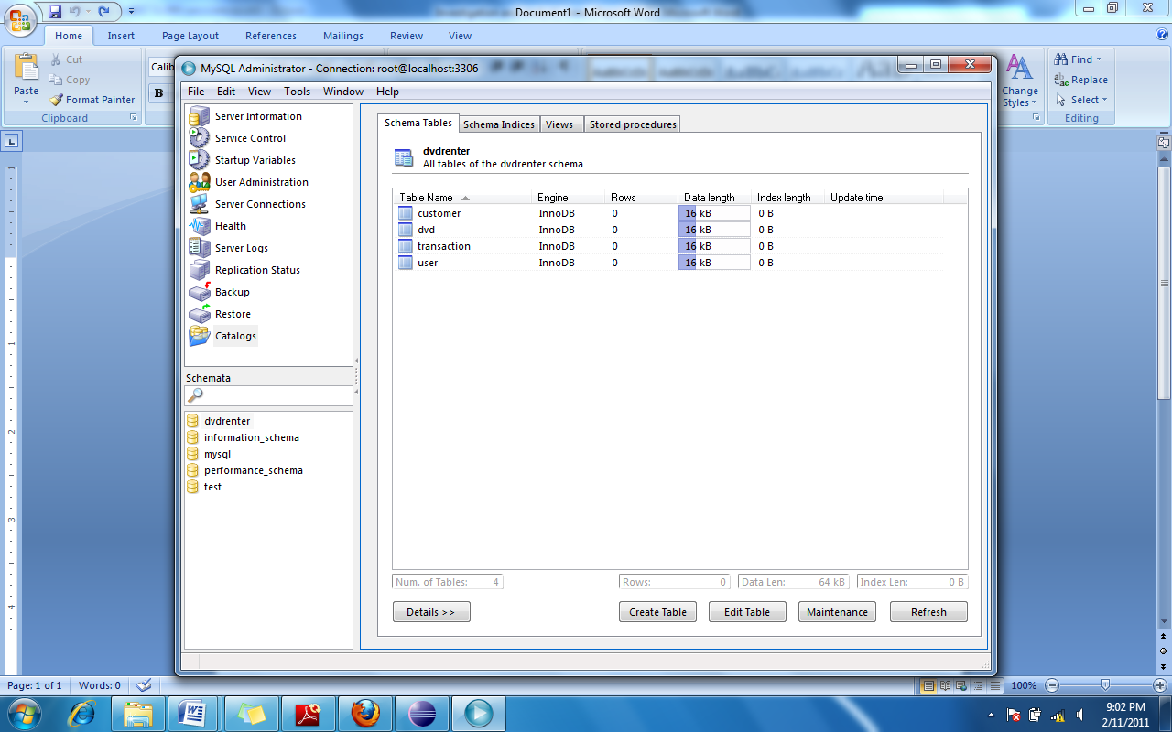

Figure ‑: Database tables

### Customer Table

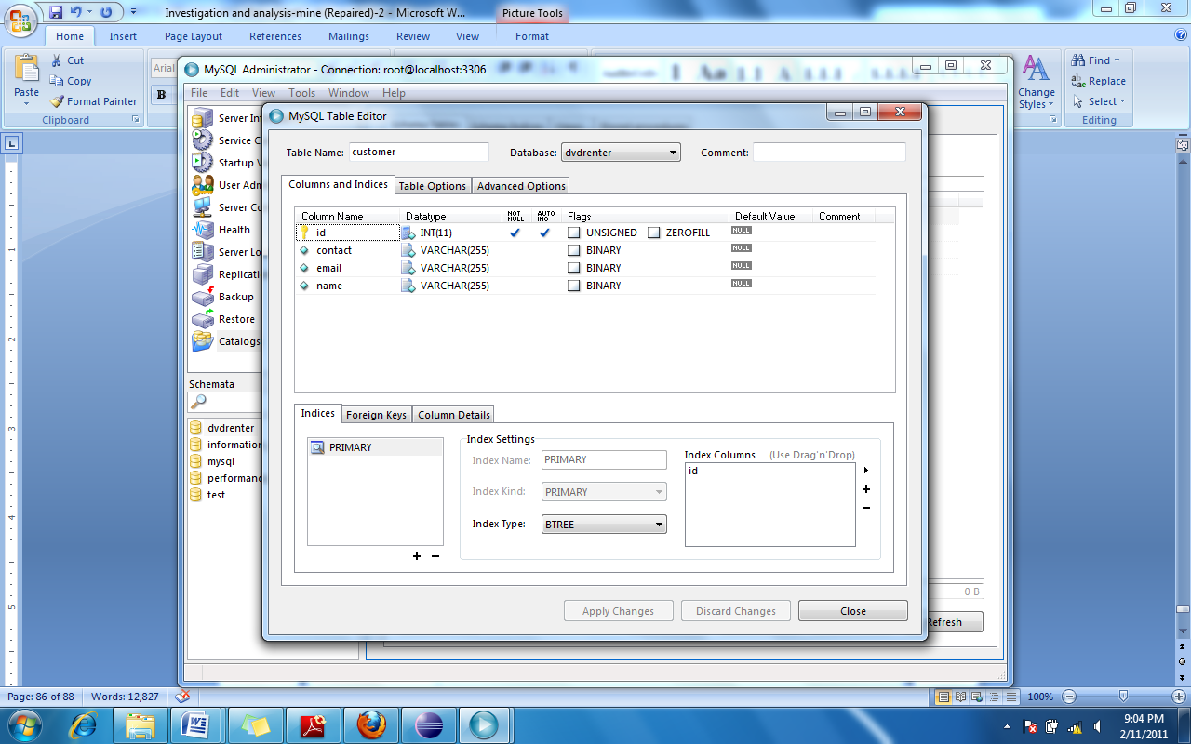

Figure ‑: Customer Table

### DVD Table

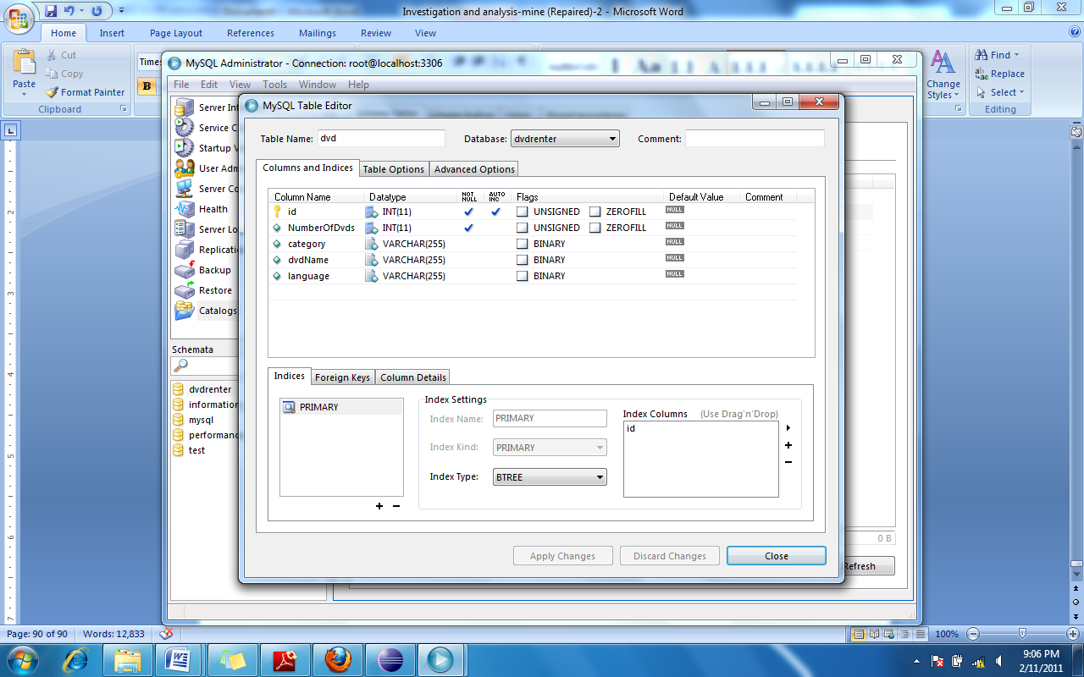

Figure ‑: DVD Table

### Transaction Table

Figure ‑: Transaction Table

### User Role Table

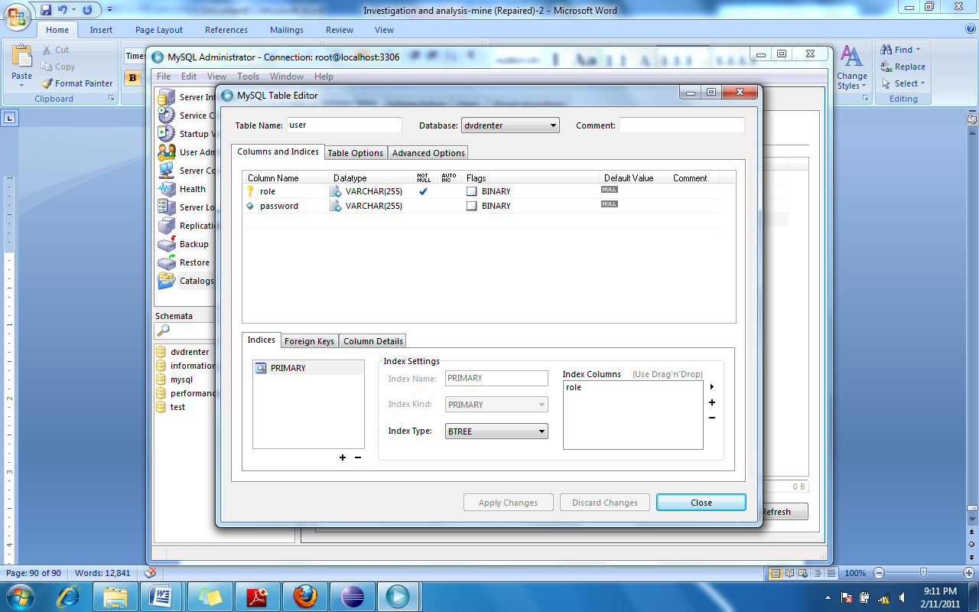

Figure ‑: User Table

# Testing

System testing was carried out according to the test plan in section 4.2. Unit tests were carried out while coding. Integration testing was carried out by executing the code from the IDE. Both unit and integration testing was carried out while developing the solution.

## Functional Testing

Functional testing was done by means of black box testing and the test cases are categorized in to two groups.

1. Basic functionality testing
2. Validation testing

### Basic functionality testing

#### Test case table for basic functional testing

This table includes all the test cases that were executed in basic functional testing.

|  |  |  |  |  |  |
| --- | --- | --- | --- | --- | --- |
| Requirement Id | Test case Id | Description | Expected Result | Actual Result | Status |
| 1. a | FT1 | Fill all customer data text boxes with valid data and click Add button and check the database. | The customer details should be available in the customer table in database. | Customer data was available in database. | Pass |
| 1. b | FT2.1 | Fill all DVD data text boxes in DVD form and click add button | The DVD details should be added to the table in the form. | A new record appeared in the table with the given DVD details. | Pass |
| FT2.2 | With several DVD records in the table in DVD form, click the save button and check the database. | All the records that were in the table should be there in the DVD table in database. | All the records that were in the DVD form were present in the DVD table in database. | Pass |
| 1. c | FT3.1 | Select a customer and DVD from the tables and click the lend button in Main form. | 1. A record should be added to the transaction table in Main form.  2. Required fields in the Transaction section should be filled. | 1. A record was added to the table.  2. All the required fields are filled in the Transaction section. | Pass |
| FT3.2 | Click the ok button in the Main form and check the Transaction table in database. | A transaction record should be available in the table with correct data. | A record is available in the table with correct data. | Pass |
| 1. d | FT4 | Fill all the data in change password form and click the save button and try to login to the system with new password. | Should be able to login to the system. | User can login to the system with the new password. | Pass |
| 2 | FT5 | Add several transactions to the table in the Main form by using lend button | The values appear in the text boxes in transaction section should be correct | The values calculated are correct. | Pass |
| 3. a | FT6 | Type a name of a customer (which exist in database) in the customer name text box in Main form | The details of the customer should be visible in the customer table in Main form. | A record appears with the customer details in the table. | Pass |
| 3. b | FT7.1 | Type a code (which exist in database) DVD in the DVD code text box in Main form. | A record should appear in the DVD table in the Main form with correct DVD code. | A record appears in the DVD table with correct DVD code. | Pass |
| FT7.2 | Type a name (which exists in database) in the DVD name text box in Main Form. | A record should appear in the DVD table in the Main form with correct DVD name. | A record appears in the DVD table with correct DVD name. | Pass |
| FT7.3 | Select a DVD language (which exists in database) from the combo box in Main form. | All the records in the database for that language should appear in the DVD table in Main form. | All the records in the database for that language appear in the DVD table. | Pass |
| FT7.4 | Select a DVD category (which exists in database) from the combo box in Main form. | All the records in the database for that category should appear in the DVD table in Main form. | All the records in the database for that category appear in the DVD table. | Pass |
| 3. c | FT8 | Login to the system with correct user role and password. | User should be able to successfully login to the system. | User can successfully login to the system. | Pass |
| 4 | FT9 | Click on the Daily Report menu item in the Main form. | The daily report should appear with correct data. | Nothing happens when the menu item is clicked | Fail |

#### Evidence of basic functionality test case execution

FT1: Before clicking the ‘Add’ button

The ID field is empty and will be filled when the customer is added to the DB.

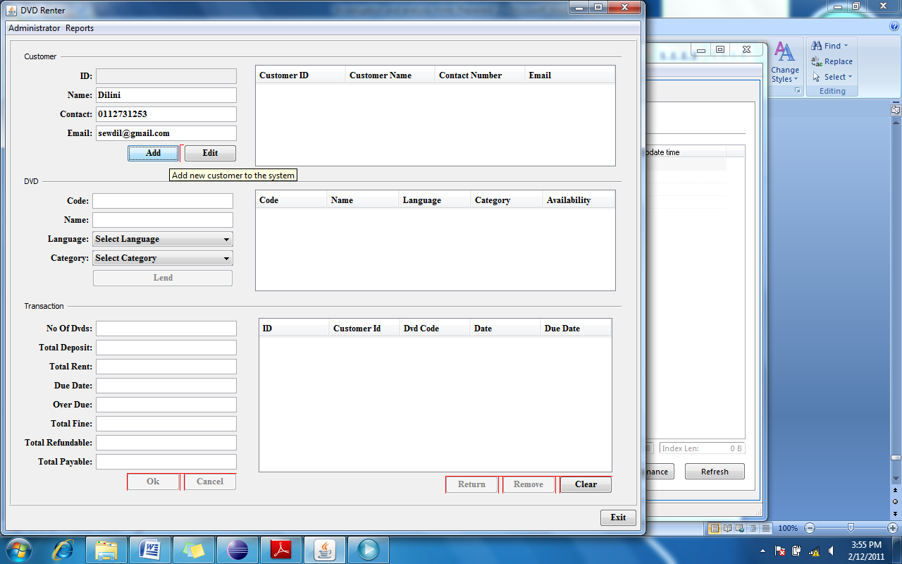

Figure ‑:FT1 Before

FT1: After clicking the ‘Add’ button

The auto incremented customer id is visible in the ID field and a record has been added to the customer table.

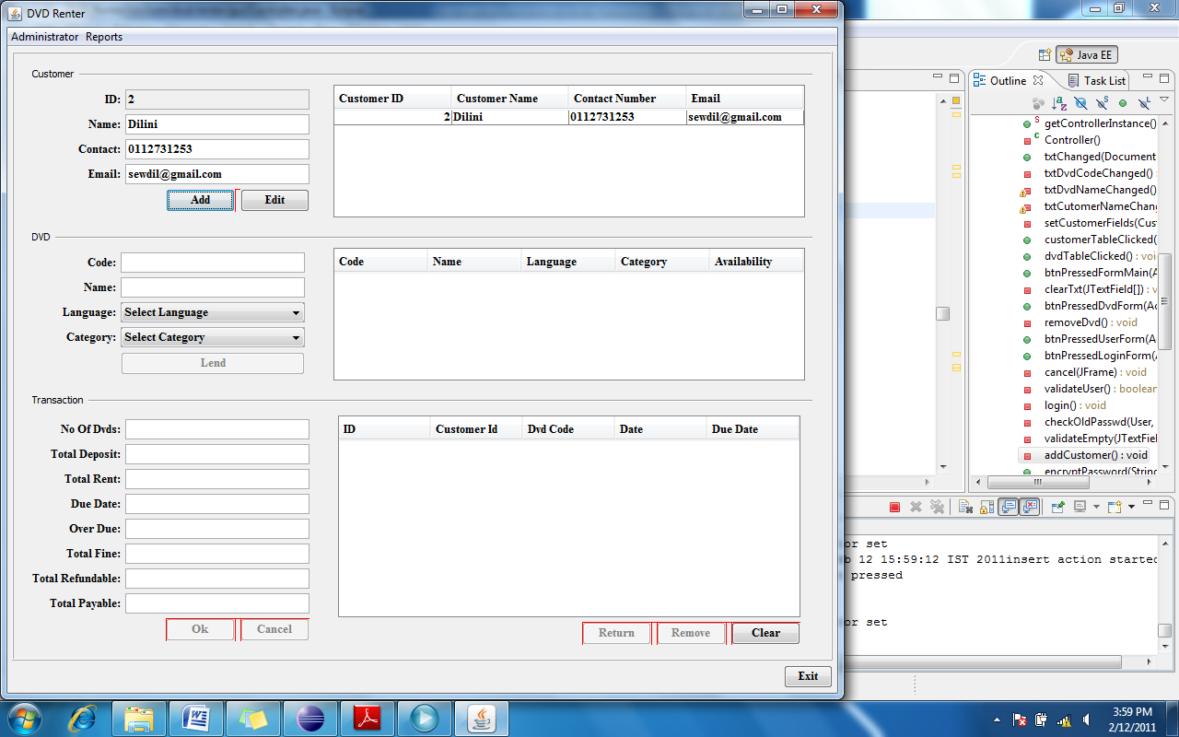

Figure ‑: FT1 After

FT1: Database after clicking the ‘Add’ button

Customer details which are added through the Main form are visible in database.

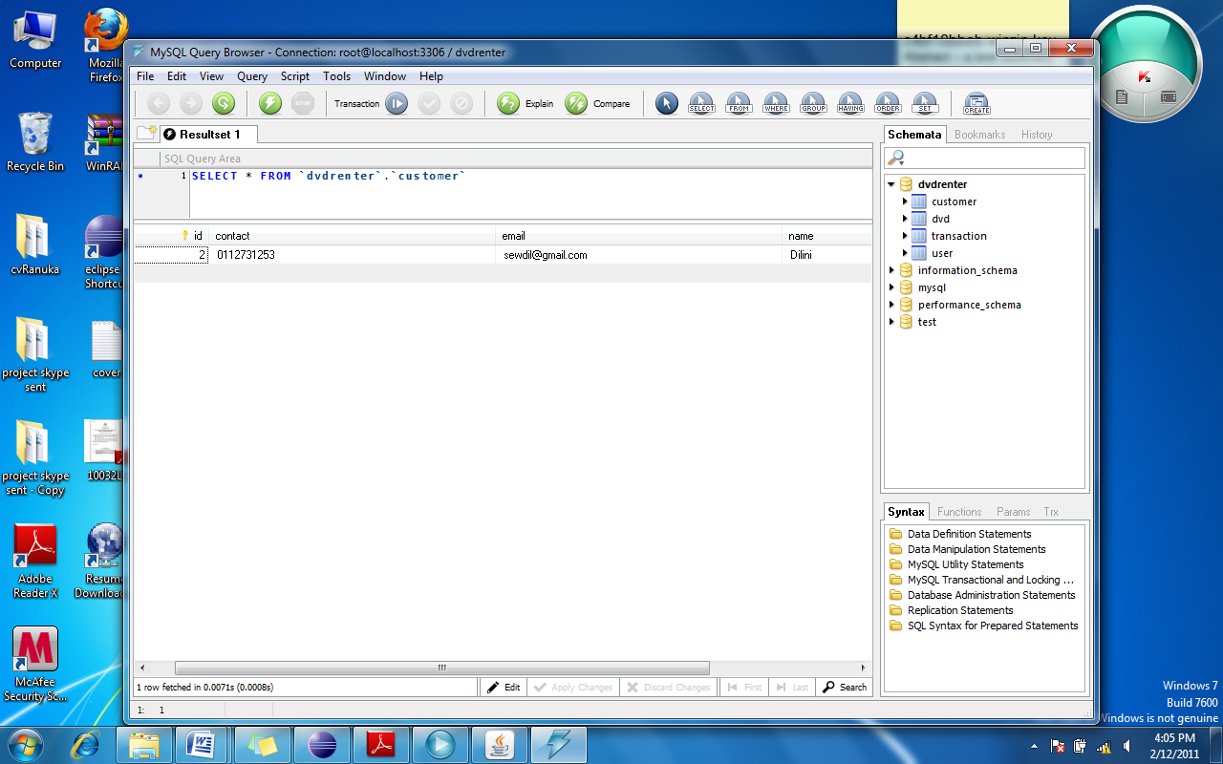

Figure ‑: FT1 Database

FT2.1: Before clicking the ‘Add’ button

The save button is disabled until Add button is clicked and a record is added to the table below. User can add several DVDs to this table before clicking the save button which actually saves each record in database.

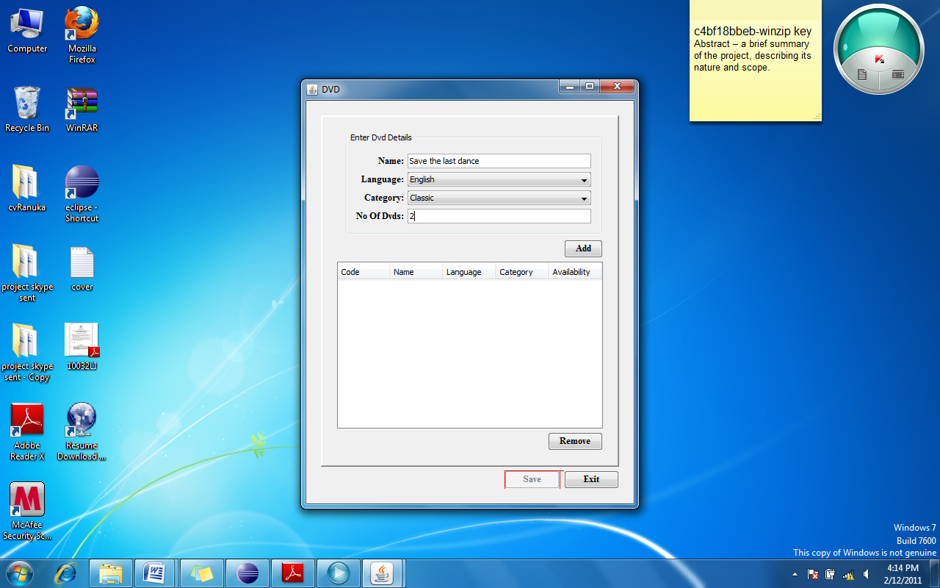

Figure ‑: FT2.1 Before Adding

FT2.1: After clicking the ‘Add’ button

The save button has been enabled and a record is added the table below. The code field in the table shows as zero since the data has not been saved in database yet and therefore the auto generated primary key has not been returned. Also all the text boxes and combo boxes are cleared so that a new entry can be done.

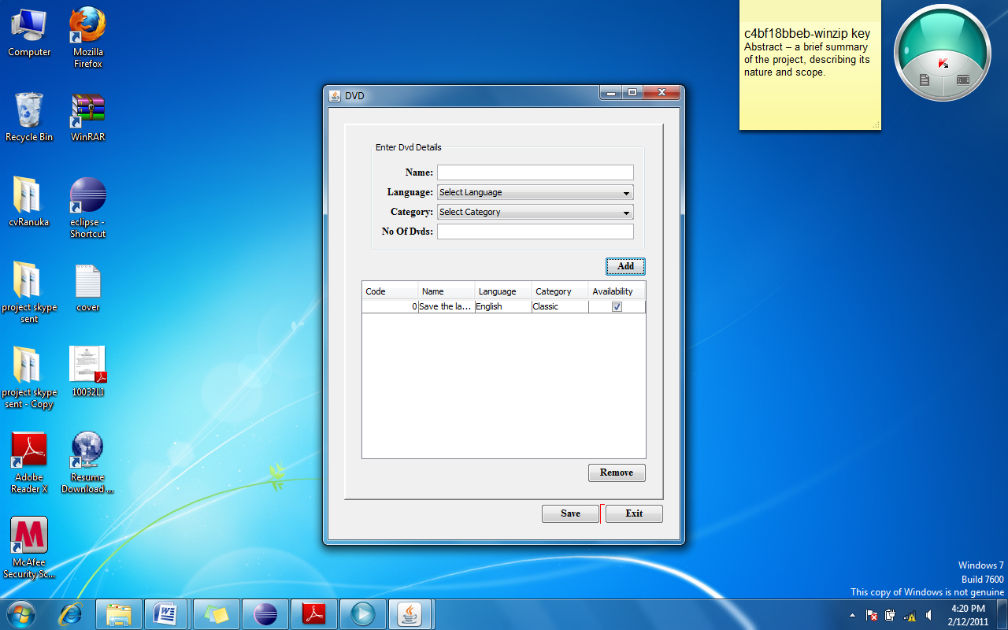

Figure ‑: FT2.1 After Adding

FT2.2: Before clicking the ‘Save’ button

Several DVD have been added to the table and the DVD code is zero since they have not been saved yet.

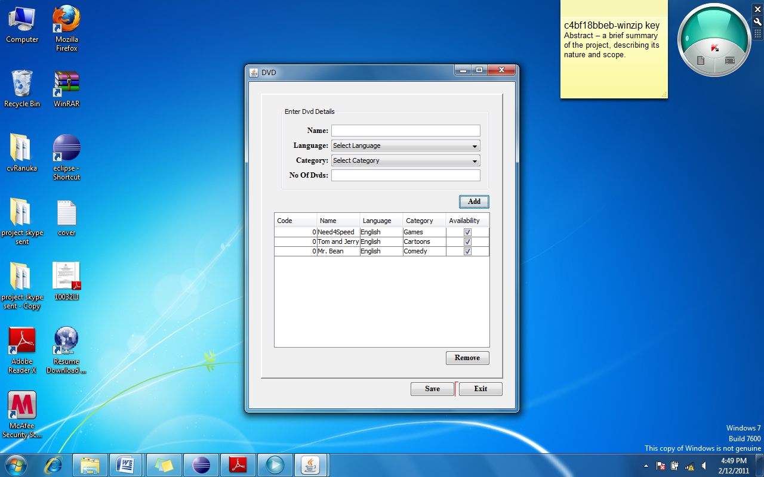

Figure ‑: FT2.2 Before saving

FT2.1: After clicking the ‘Save’ button.

The auto generated DVD codes are displayed in the table which means that the records have been saved in database successfully, and the save button is disabled again.

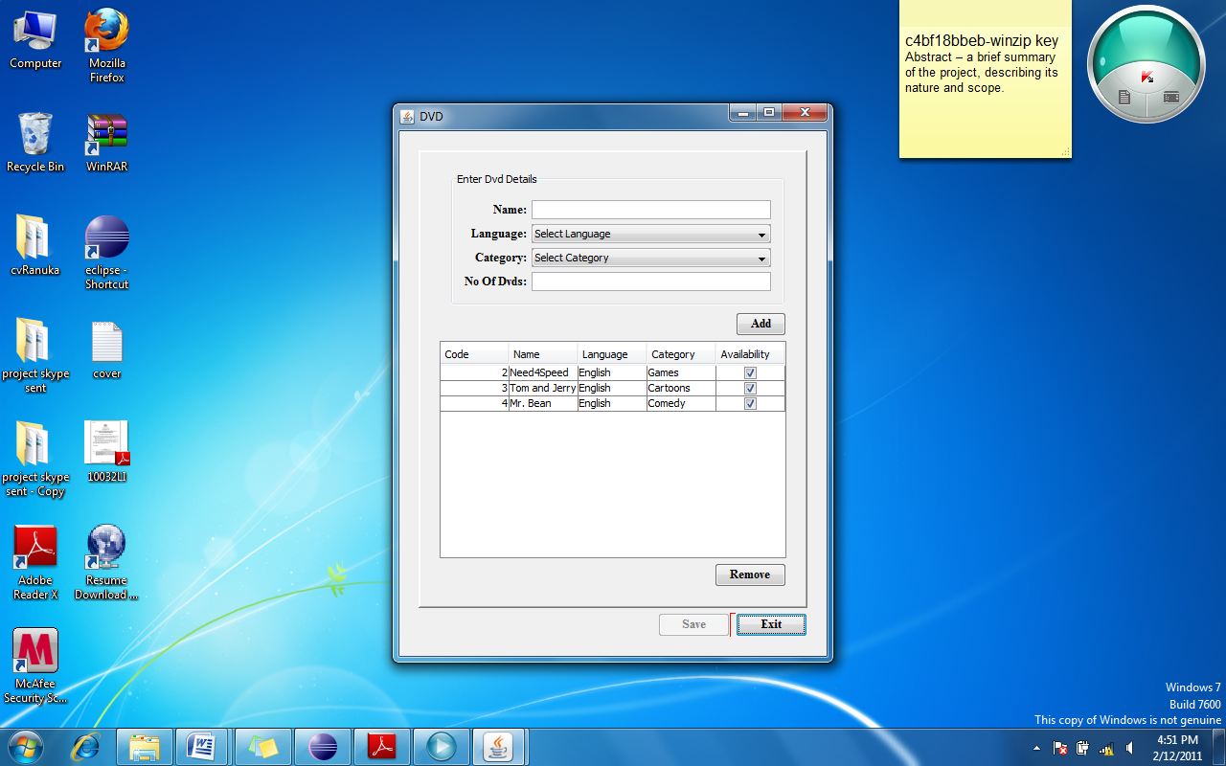

Figure ‑: FT2.2 After saving

FT2.2: Database after saving

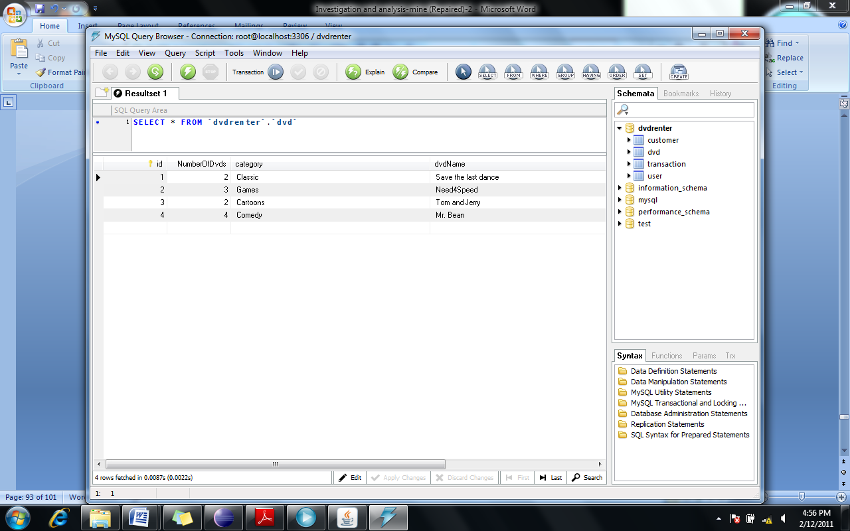

Figure ‑: FT2.2 Database

FT3.1: Before clicking the ‘Lend’ button

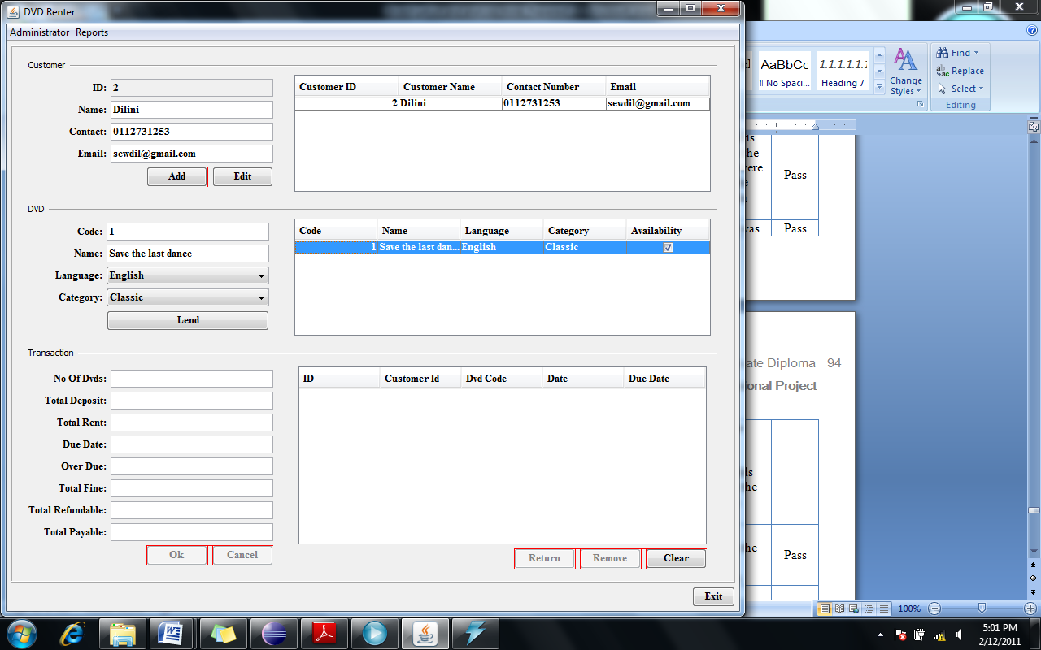

Figure ‑: FT3.1 Before lending

FT3.1: After clicking the ‘Lend’ button

A record is added to the transaction table and the text fields are filled with calculated data.

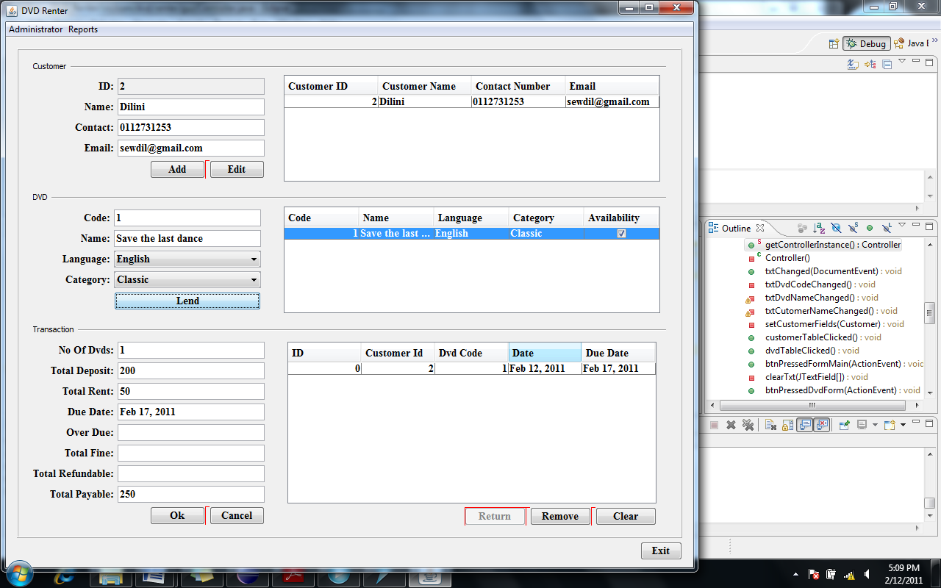

Figure ‑: FT3.1 After lending

FT3.2: After clicking the ‘OK’ button

The text boxes in the customer section have been cleared so that a new entry can be done easily.

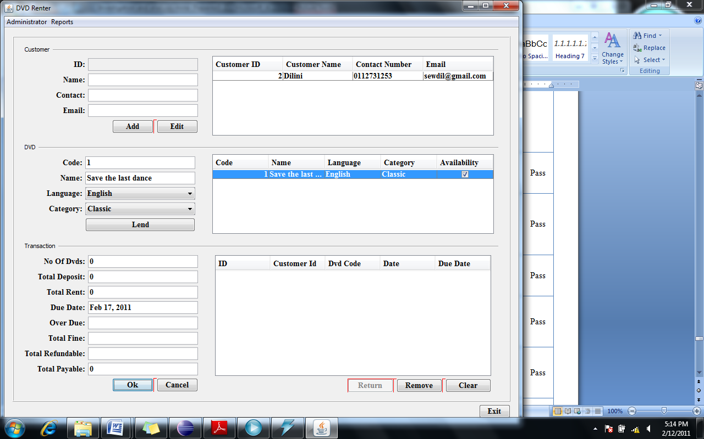

Figure ‑: FT3.2 After Saving

FT3.2: Database after saving the transaction

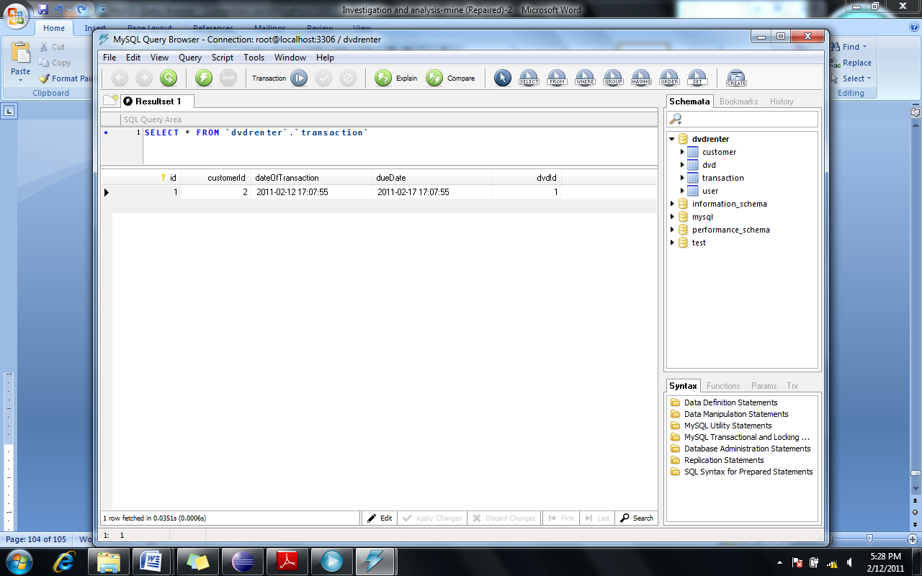

Figure ‑: FT3.2 Database

FT6:

When the user starts to type a name of a customer, all the customers with similar names are listed in the customer table.

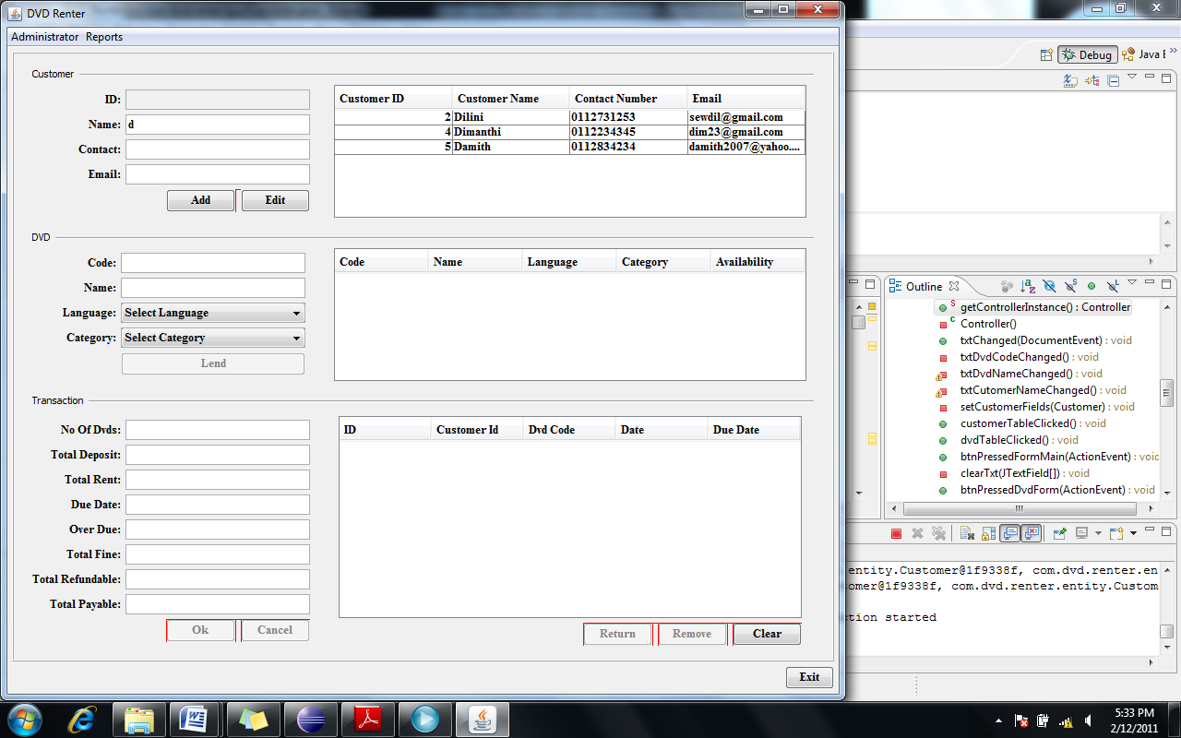

Figure ‑: FT6

When the user clicks on the record in the table, all the details will be filled to the text boxes.

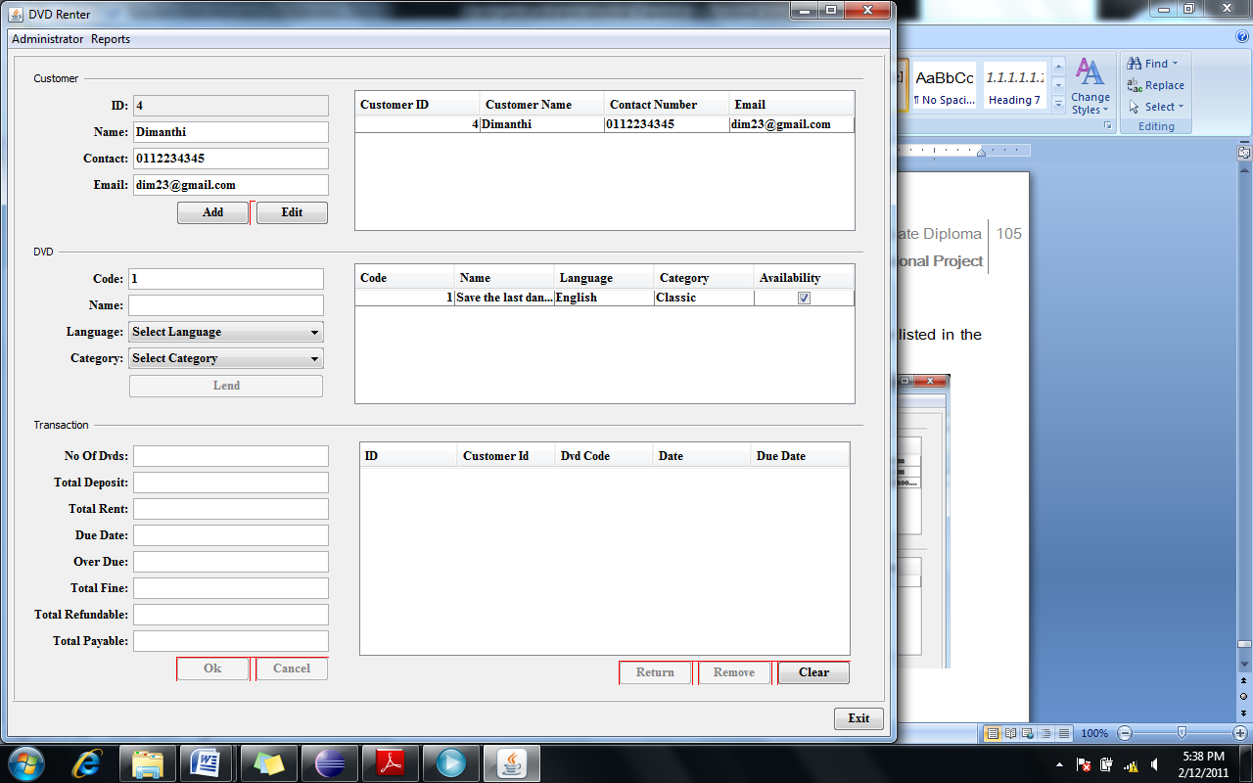

Figure ‑: FT6

FT7.1

When the user enters the DVD code, the record for the particular DVD will be listed in the table.

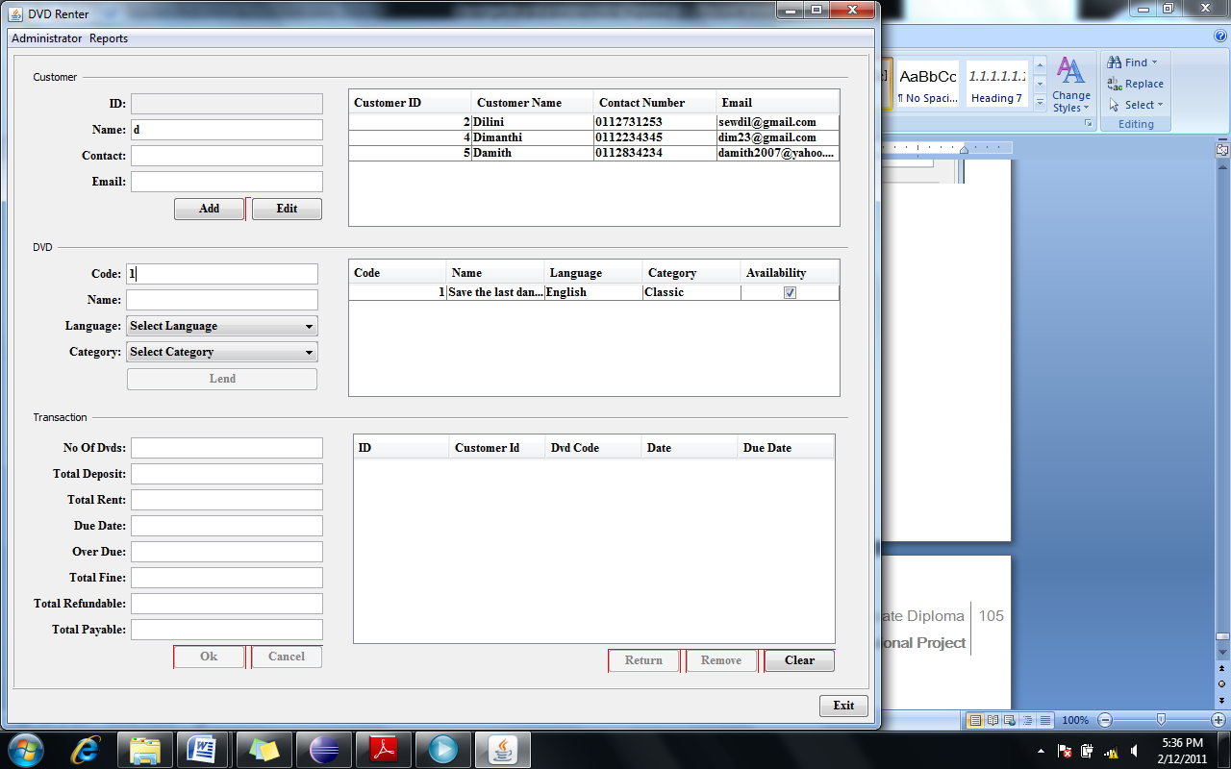

Figure ‑: FT7.1

FT7.2

When the user selects a language, all the DVDs saved under that language will be listed in the table.

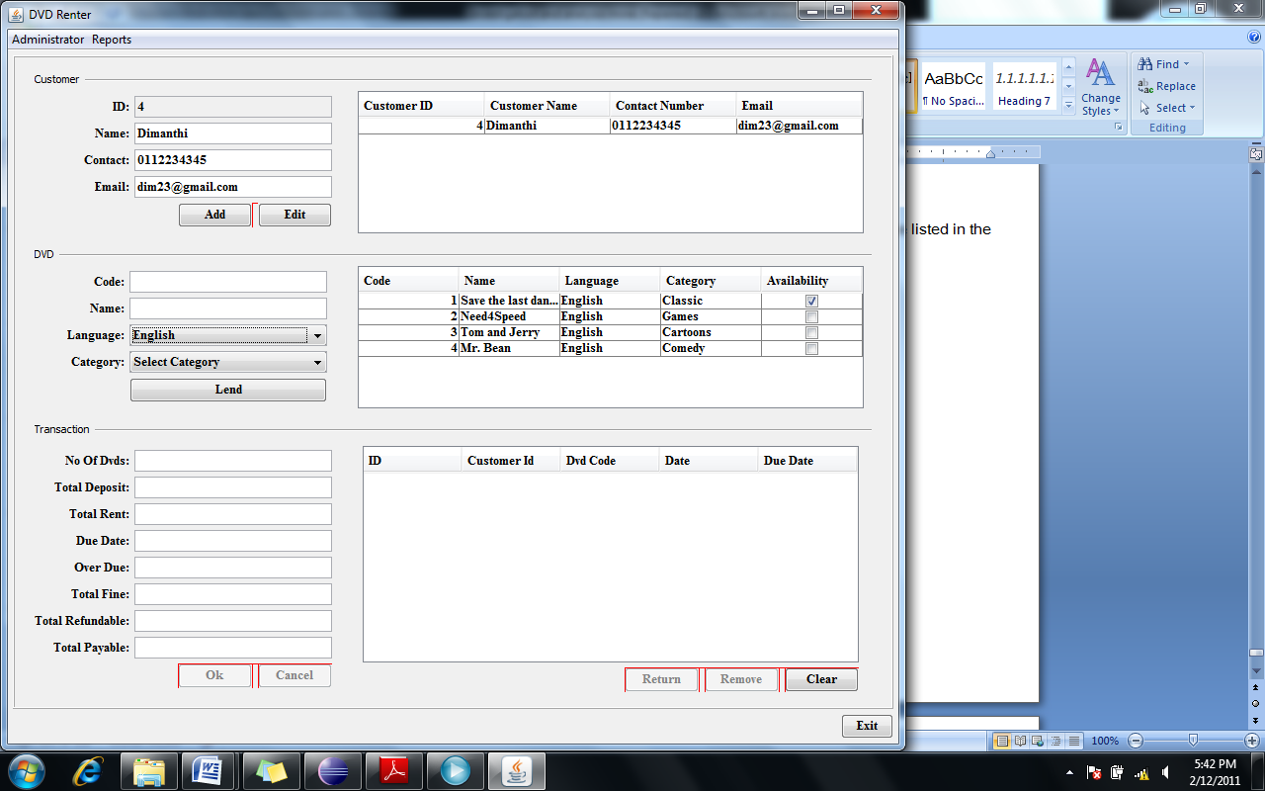

Figure ‑: FT7.2

### Validation testing

#### Test cases for validation testing

This table includes all the test cases that were executed in validation testing.

|  |  |  |  |  |  |  |  |
| --- | --- | --- | --- | --- | --- | --- | --- |
| Form | Field | Functionality | Test case Id | Validation | Expected result | Actual result | Status |
| Login form | User Role | Login | VT1 | Presence check | Display error message box | Display error message box | Pass |
| Password | VT2 | Pass |
| Main Form | Customer name | Add Customer | VT3 | Presence check | Display error message box | Display error message box | Pass |
| Contact | VT4 | Pass |
| Email | VT5 | Pass |
| DVD Code | Add transaction | VT6 | Presence check | Lend button should be disabled until all fields are filled | Lend button is disabled until all fields are filled | Pass |
| DVD name | VT7 | Pass |
| Category | VT8 | Pass |
| Language | VT9 | Pass |
| DVD form | DVD name | Add DVD | VT10 | Presence check | Display error message box | Display error message box | Pass |
| Category | VT11 | Pass |
| Language | VT12 | Pass |
| No of DVDs | VT13 | Pass |
| Change password form | User role | Change password | VT14 | Presence check | Save button should be disabled until all fields are filled | Save button is disabled until all fields are filled | Pass |
| Current password | VT15 | Pass |
| New password | VT16 | Pass |
| Confirm new password | VT17 | Pass |

#### Evidence of validation test case execution

VT1

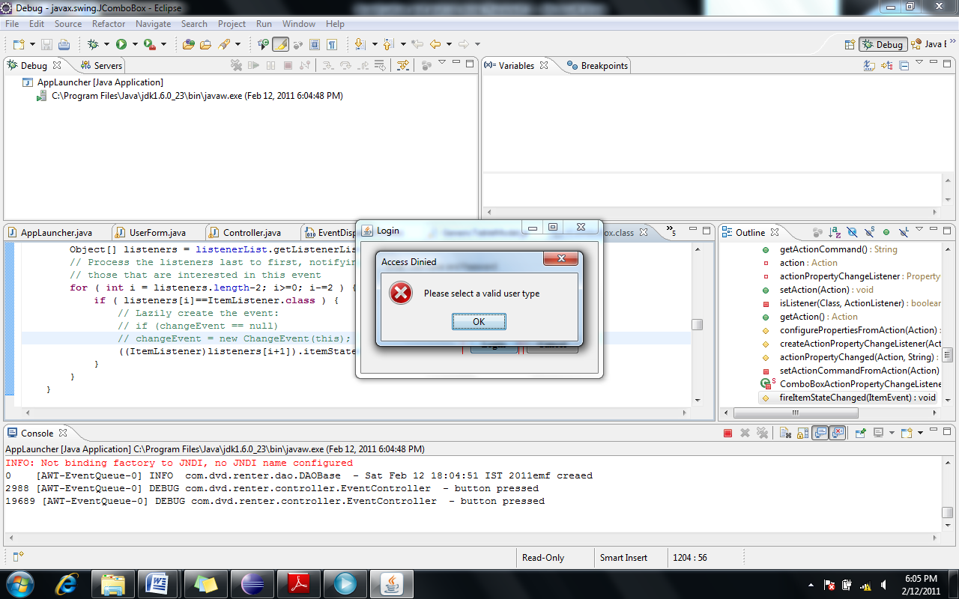

Figure ‑: VT1

VT2

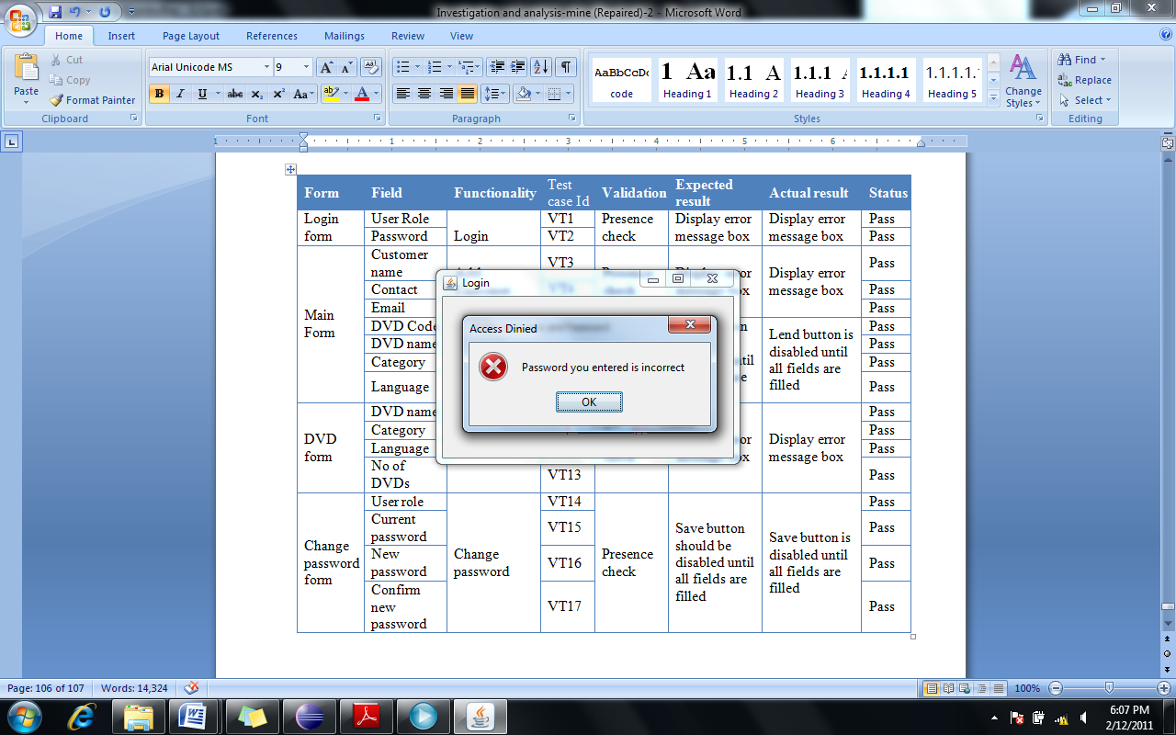

Figure ‑: VT2

VT3

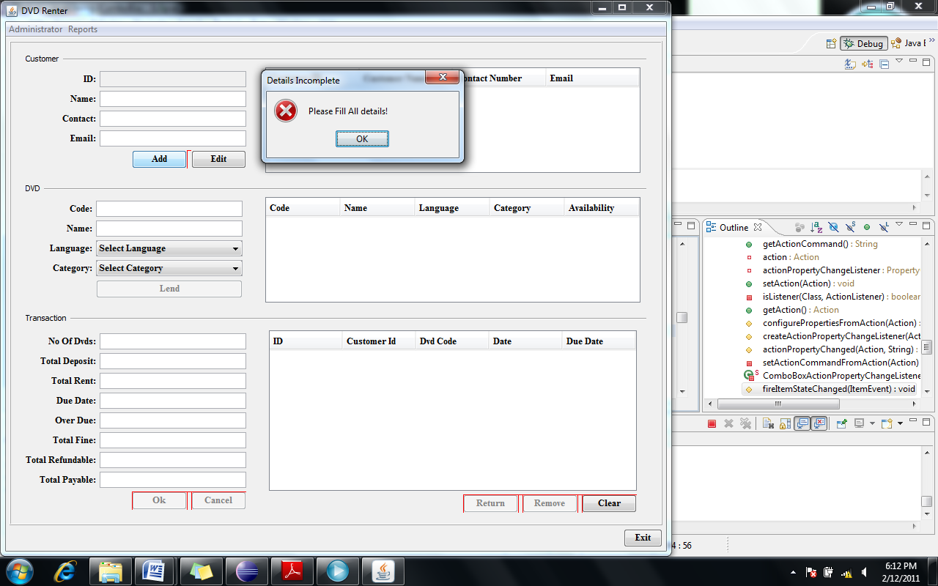

VT4

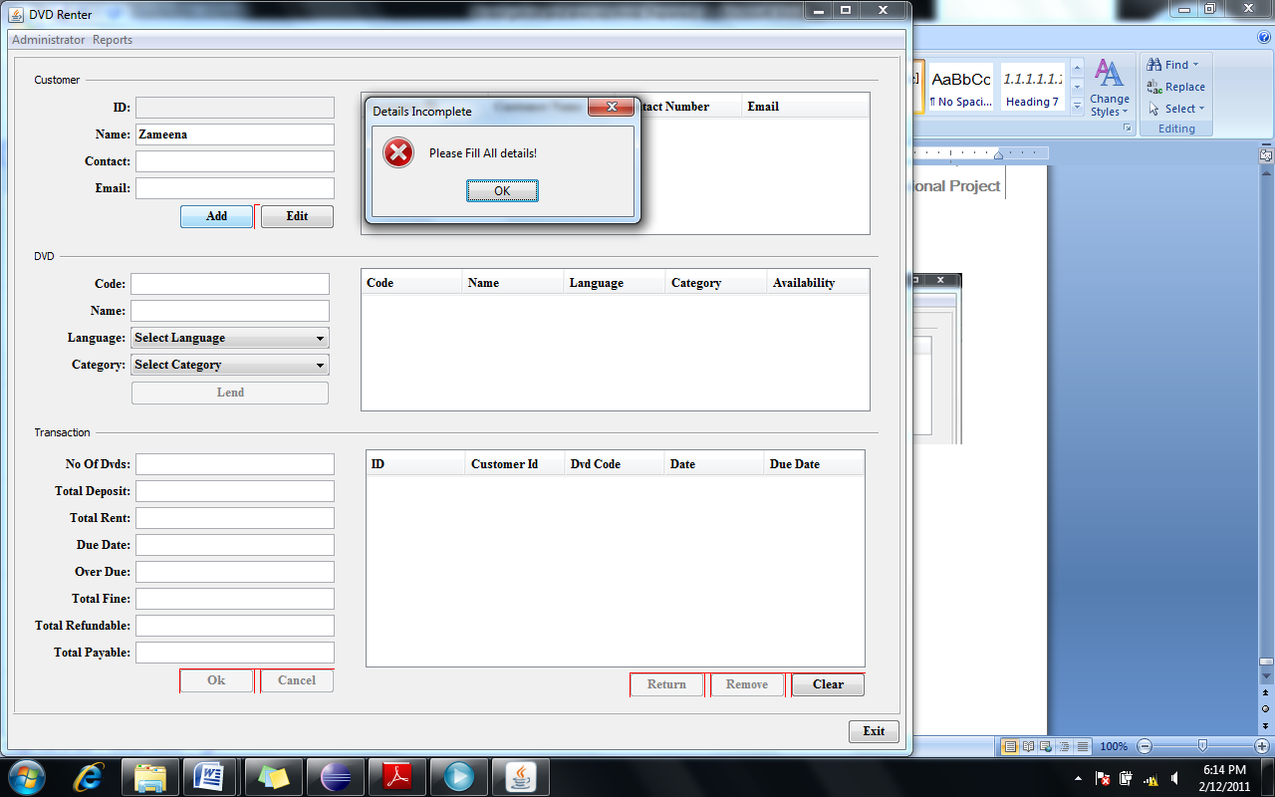

Evidence for VT6-VT9 can be found in FT7.1

VT10 to VT13

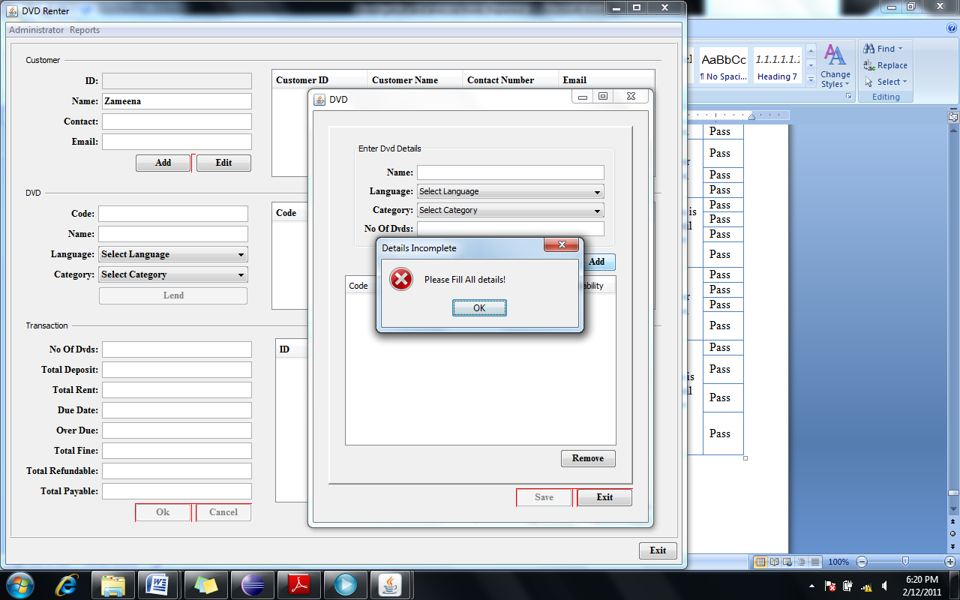

VT14 to VT17

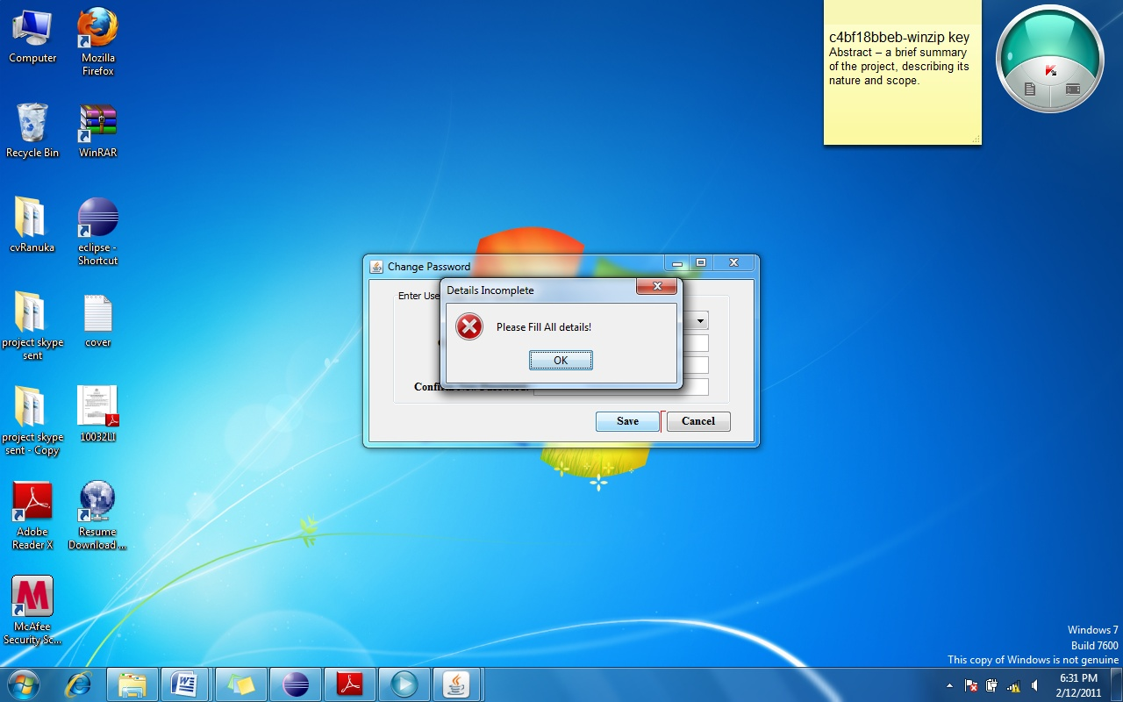

# Critical Appraisal

The DVD renting system for the Southern DVD Center has been implemented successfully at the customer location, and the users (Mr. Rathnayaka and cashier) have responded positively and accepted the system since most of the system requirements were met by the implemented system.

Object oriented analysis and design methodology was followed and UML modeling was used to elaborate the system design. Choosing OOAD over SSADM was a right decision since it simplified the design, for example, system design was simplified by the usage of object oriented modeling since the business objects were modeled rather than business procedures. And also it increased the productivity, for example, reusability of components like the domain objects and the reusability of methods and functions highly increase the productivity. OOAD allowed me to design and develop the system with minimum coupling between components but with high cohesion and distribute the responsibility to each component of the system meaningfully so that it increases reusability. Reusability also increases system maintainability and extendibility for example, if it is required to incorporate renting for some item other than DVDs, it is just a matter of creating another domain object and using it in appropriate places which will not affect or break already implemented functionalities. Also the usage of MVC design pattern in the system front end was successful because it clearly separates the business logic from the user interfaces and therefore increases maintainability and extendibility, for example the user interfaces can be changed without touching the business logic and the business logic can be reused in any user interface where appropriate.

If the system design was more elaborative, the implementation would have been more simple and easy. Some of the design decisions had to be taken at the implementation level, like the package structure of the project and the detail design of the controller and the view components. At the system design level, class diagrams for the controller component and the views were not produced; instead the classes were just evolved as appropriate at the stage of implementation, this lead to some rework.

Implementation was simplified by the usage of some of the APIs like JPA and open source libraries like Jgoodies and open source frameworks like Hibernate for example, database handling implementation was made very simple and productive by the usage of JPA and Hibernate. The advantages of using such frameworks are they are well known, used and well tested; therefore testing effort for the functionalities provided by the framework is very less. Also they allow separation of responsibilities for example, if the user preferred to change the database from MYSQL to Oracle, it can be done without doing any code changes.

The user interface implementation lacks the look and feel of professional software and also a lot of time had to be spent on creating the user interfaces and implementing the input validations than estimated. This is mainly due to not using a proper framework or set of libraries that provide more support for user interface development. The Jgoodies forms library that was used contained defects due to which, the red markings appeared around buttons in the GUI forms. A better approach to user interface design should have been taken. The Spring Rich Client is a great framework for user interface development which includes built-in validations support, but it required more time to learn it.

Testing of the system could be carried out as per the test plan and was successful. The unit testing was done by means of white box testing but a better approach would have been to use a unit testing framework like JUnit which will allow more intense testing and is less time consuming. The number of test cases written for functional testing and input validation testing was not sufficient but within the time constraints the basic functionality could be tested thoroughly. One test case in functional tests failed because that functionality could not be implemented. The report generation was a functionality that the customer was looking forward to, but it could not be implemented within the time frame and the customer was promised that it will be implemented later on.

There are some very important lessons that have been learned during the course of this project. One is that one should not jump start implementation of software without elaborating the design as much as possible. The system design is very important and detail design of each component of the system makes implementation very productive and simple and also minimizes rework. Another very important lesson is that a proper analysis should be done before choosing technologies, frameworks or external libraries to be used in implementation for example the choice of Jgoodies form library for user interface design was a blunder. An estimate of the time and effort should be made only after a thorough analysis of such support available for use. In such cases one should look for proper and complete documentation, user support and stability of the project if it is an open source or free software. The decision to use well known design patterns and frameworks is successful and saves a lot of time and effort at implementation stage and also helps to develop a clear design, and one should always look for such possibilities and use them as appropriate.

# Works Cited

1. Microsoft Access vs. Microsoft SQL Server. *databasedev.co.uk.* [Online] [Cited: 10 20, 2010.] http://www.databasedev.co.uk/ms-access-vs-sql-server.html.

2. MySQL Community Server. *MySQL.* [Online] [Cited: 12 24, 2010.] http://www.mysql.com/downloads/mysql/.

3. **Sierra, Kathy and Bates, Bert.** *Head First Java.* s.l. : O'REILLY.

4. **Freeman, Eric T, et al.** *Head First Design Patterns.* s.l. : O'Reilly Media, 2004.

5. Object-oriented analysis and design. *Wikipedia, the free encyclopedia.* [Online] [Cited: 11 20, 2010.] http://en.wikipedia.org/wiki/Object-oriented_analysis_and_design.

6. **McLaughlin, Brett, Pollice, Gray and West, David.** *Head First Object-Oriented Analysis and Design.* s.l. : O'Reilly Media, 2006.

7. **Booch, Grady, Rumbaugh, James and Jacobson, Ivar.** *Unified Modeling Language User Guide.* s.l. : Addison Wesley, 2005.

8. Log4j. *Apache.* [Online] [Cited: 12 29, 2010.] http://logging.apache.org/log4j/1.2/manual.html.

9. Model–View–Controller. *Wikipedia, the free encyclopedia.* [Online] [Cited: 11 30, 2010.] http://en.wikipedia.org/wiki/Model%E2%80%93View%E2%80%93Controller.

10. Community Material. *Hibernate.* [Online] JBOSS Community. [Cited: 11 20, 2010.] http://docs.jboss.org/hibernate/core/3.6/quickstart/en-US/html/.

11. Creating a GUI With JFC/Swing. *The Java Tutorials.* [Online] 10 30, 201-. http://download.oracle.com/javase/tutorial/uiswing/.

12. Jgoodies Forms. *Jgoodies.* [Online] [Cited: 12 03, 2010.] http://www.jgoodies.com/freeware/forms/index.html.

13. The Java Persistence API. *Oracle.* [Online] Oracle. [Cited: 11 11, 2010.] http://www.oracle.com/technetwork/articles/javaee/jpa-137156.html.

14. JFrame at Center Screen. *Java Forums.* [Online] [Cited: 12 31, 2010.] http://www.java-forums.org/awt-swing/3491-jframe-center-screen.html.

1. MySQL Community Server. *MySQL.* [Online] [Cited: 12 24, 2010.] http://www.mysql.com/downloads/mysql/.
2. MySQL Community Server. *MySQL.* [Online] [Cited: 12 24, 2010.] http://www.mysql.com/downloads/mysql/.